
CUSTOM MLS SEARCH - PRELIMINARY QUESTIONNAIRE
* = Required Field
*First Name | 
*Last Name
*E-Mail Address
Address
*City
*State
Zip Code
Work Phone
Home Phone
Cell Phone

If you wish to be contacted to discuss our search recommendations, please indicate your preferred contact method:
- Telephone:  Home Work Cell
- E-Mail:
- Best Time to Reach You:
*If you live outside of the area, how often have you visited here?
 Never 1-5 Times 5+ Times
I am looking for the following in terms of a property purchase:
Price Range - Check all that apply:
$150-200,000 |  | $550-600,000 |  | $4Mil-5Mil
$200-250,000 |  | $600-700,000 |  | $5Mil-6Mil
$250-300,000 |  | $700-800,000 |  | $6Mil7Mil
$300-350,000 |  | $800-900,000 |  | $7Mil-8Mil
$350-400,000 |  | $900,000-1Mil |  | $8Mil-9Mil
$400-450,000 |  | $1Mil-2Mil |  | $9Mil-10Mil
$450-500,000 |  | $2Mil-3 Mil |  | $10 Mil +
$500-550,000 |  | $3Mil-4Mil

Type of Property:
Single Family Home - Resale
Single Family Home - New Construction
Condo (known locally as a Villa) - Resale
Condo (known locally as a Villa) - New Construction
Lot/Home Site
Use and Type of Property:
Short-Term Rental/Vacation - A furnished property that will be rented by the week, and may be used for personal vacations two weeks a year.
Long Term Rental - An unfurnished property that will be rented on an annual basis.
Second Home - A property that will be used periodically, but will not be rented
Residential - A permanent residence

Please select the one answer that most closely describes your objective. | Required | Nice  To Have | Don’t  Care | Can’t  Accept
Location Preference, If Any
Charlotte Area
Fort Mill/Rock Hill Area
Location and View
Lake Norman Area
Lake Wylie Area
Lake View
Dock
Walking distance to lake
Golf course view
Marsh view
Marina/Harbor view
Wooded view
Deep water view
Neighborhood Amenities | Required | Nice to Have | Don’t Care | Can’t Accept
Golf
Private Golf Country Club
Private Golf Club
Semi-Private Golf Club
Public Golf Club
Boating
Water Activities
Lake Access
Fishing
Kayaking/canoeing
Recreation
Fitness Center
Leisure Trails
Playground
Social Clubs
Stables
Tennis Courts
Other | Required | Nice to Have | Don’t Care | Can’t Accept
Activity Director
Age Restricted (55 and older)
Children-Friendly
DSL High-Speed Internet Service
Pets Allowed
How Important is Close Proximity To:
Active volunteer organizations
Art and entertainment venues
Assisted-living or nursing home care
Hospitals
Schools: K-12
Schools: Higher/continuing education
Shopping

If any specific communities or areas have caught your attention, please list them below:
Use the space below to tell us things that may impact our Custom Search suggestions, for example, if you’re looking for a retirement home or investment, you must have five bedrooms, a workshop in the garage, a guest house, etc.



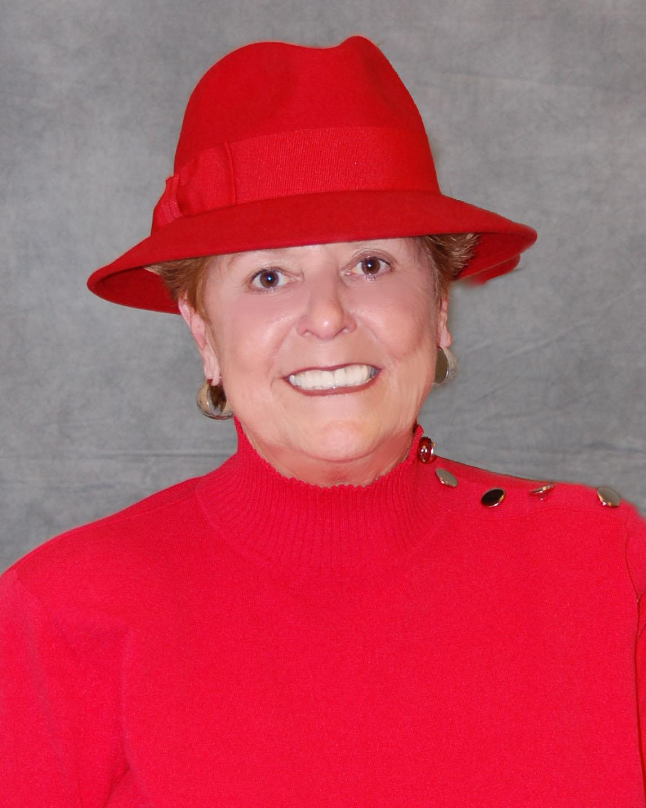
Barbara McGill
Realtor/Broker
Keller Williams Ballantyne
Mobile: (704)641-4516
Office: (704)496-7508
Email: bmcgill@kwcharlotte.com

VIRTUAL TOUR AT :
plansandtours.com/1019263


Barbara McGill
Realtor/Broker
Keller Williams Ballantyne
Mobile: (704)641-4516
Office: (704)496-7508
Email: bmcgill@kwcharlotte.com

VIRTUAL TOUR AT :
plansandtours.com/1019263
Barbara McGill
Realtor/Broker
Keller Williams Ballantyne
Mobile: (704)641-4516
Office: (704)496-7508
Email: bmcgill@kwcharlotte.com

VIRTUAL TOUR AT :
plansandtours.com/1019263

704-641-4516
bmcgill@comporium.net
www.Move-To-Charlotte.com
www.barbaramcgill.yourkwagent.com

704-641-4516
bmcgill@comporium.net
www.Move-To-Charlotte.com
www.barbaramcgill.yourkwagent.com

