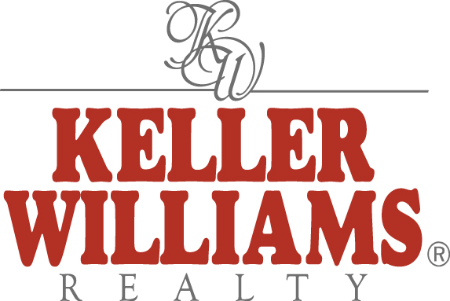
Dear Friends,
KELLER WILLIAMS® REALTY
2410 L & N Drive • Huntsville, AL 35801 • 256-705-0734 • 256-519-7242
www.kw.com
Each Keller Williams Office is Independently Owned and Operated

I am very excited to let you know that I have recently joined America’s fastest growing and most innovative real estate company, Keller Williams Realty. I am excited to be part of this dynamic group of Realtors who believe in the same work ethic as I do. Keller Williams Realty, like me, believes that the customer always comes first and your complete satisfaction is our main goal.

You, my clients and friends, are the reason for the successes that I have experienced thus far in my 22 year real estate career. Thank you for all that you have done. I hope that I have earned your loyalty, and appreciate your support as I transition to my new company.

It is my pleasure to also announce that my husband, Carl, has joined me at Keller Williams! We are excited about forming our real estate team, and along with our assistants, look forward to working with you all for many years to come. My cell phone number remains the same, 256-797-6847. You may also contact us at our office, located at 2410 L & N Drive, Suite C, just off Bob Wallace Avenue. Our direct office number is 256-705-0734.

Let us know if we can help you or a friend with any residential or commercial real estate needs. Call me anytime!


Tobye and Carl Scheer
Office: 256-705-0734
Cell: 256-797-6847

Email: tscheer5@comcast.net
carlscheer@kw.com
Web: www.tobyescheer.com
www.carlscheer.com

