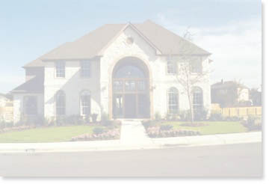
123 Canyon Rim Dr. Austin, TX

Property Description:
Placing a Photo:
1. Click on current photo and hit delete key.
2. Go to Insert menu and choose Picture and then From File. (photo will be in text mode by default)
3. Right click on that photo and choose Format Picture.
4. Click on Layout tab at top of dialog box and choose ‘In Front of Text’ option.
5. Click on the Advanced button next and unclick the option for Move Object With Text.
Great Two Story Home On A Spacious 3/4 Acre Lot! Living Room With Brick Fireplace. Formal Dining Or Second Living Area Off Kitchen. Split Bedroom Plan. Spacious Country Kitchen With Plenty Of Cabinets And Eating Area.

Special Features:
SQ. FT. = 1777, # OF BEDROOMS = 4, #BATHS = 2 ½, GARAGE (CARS) = 2, Double Vanity, Indoor Utilities, In-
YEAR BUILT =5
EXTERIOR = Frame/Brick Veneer, Masonry on One Side
ROOF TYPE = Composition Shingle
COOLING = Central Air HEATING Central Heat, Electric ENERGY = Ceiling Fan(s)

Gary Keller
Contact me:
ONLY $249,000!
5555 South Street
Austin, TX 78746
Phone: (555) 555-5555
Fax: (555) 555-5555
Mobile: (555) 555-5555
emailme@myaddress.com
Visit my site at:
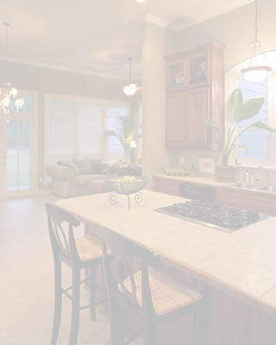
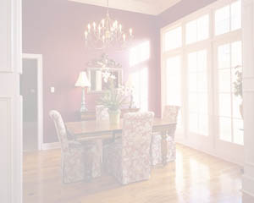
http://www.mywebsite.com
Placing a Photo:
1. Place a photo on top of this box.
2. Right click on that photo and choose Format Picture.
3. Click on Layout tab at top of dialog box and choose ‘In Front of Text’ option.

