Note: Blackberry setup varies by device.
The following instructions are based on a Torch. Your experience may be different.

- From your device’s mail screen click
“Set up another email account”
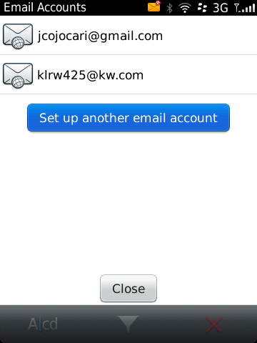

- Select Gmail.
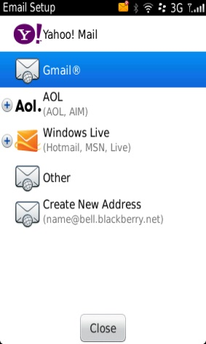

- To get access to the advanced mail setup, Enter your full @kw.com email address and any incorrect password, then click Continue
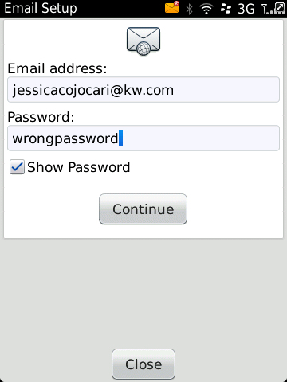

- Select “I will provide the settings”
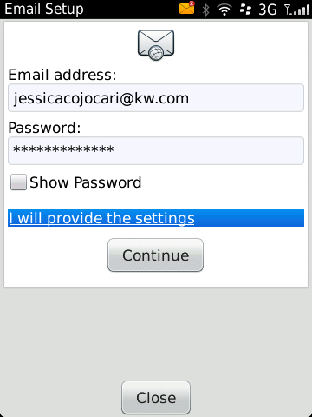

- Enter the following then click Continue:
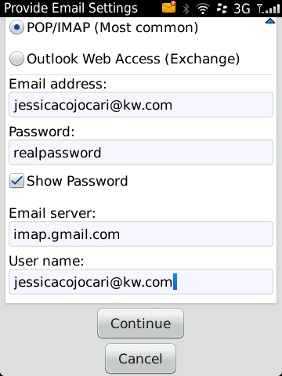

Email Address: | Your full @kw.com email address
Password: | Your MyKW password
Email Server: | Imap.gmail.com
User Name: | Your full @kw.com email address

