BERKELEY COUNTY UTILITY INFORMATION





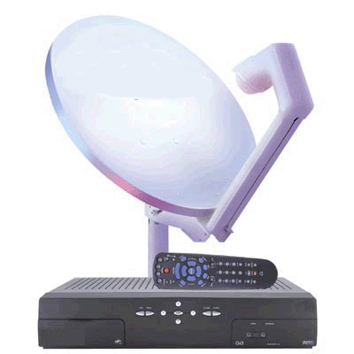
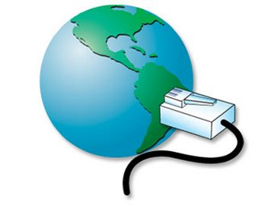
Service | Company | Phone | Address
Electricity/Gas | Allegheny Power | 1-800-Allegheny | http://www.alleghenypower.com/CSC/CSCHome.asp
Telephone and DSL (High Speed Internet) Service: | Verizon | 304-954-6200 | http://www.verizon.com
Water Service | Berkeley County Public Service Water District  83 Monroe Street  Martinsburg , WV 25404 | 304-267-4600 | http://www.berkeleywater.org/
Sewer Service | Berkeley County Public  Service Sewer District  275 Monroe Street  Martinsburg, WV 25401 | 304-267-4600 | http://www.bcpssd.com/
Trash Service | Apple Valley Waste  362 W Burr Boulevard  Kearneysville, WV 25430 | 304-724-1834  877-267-1280 | http://www.applevalleywaste.com
Cable Television and High Speed Internet | Comcast  110 Terrace Street  Martinsburg, WV 25401 | 1-888-266-2278 | http://www.comcast.com
Satellite Television 1 | Direct TV  P.O. Box 6550  Greenwood Village, CO  80155-6550 | 1-888-777-2454 | http://www.directtv.com
Satellite Television 2 | Dish, Inc. | 1-888-825-2557 | http://www.dishnetwork.com

