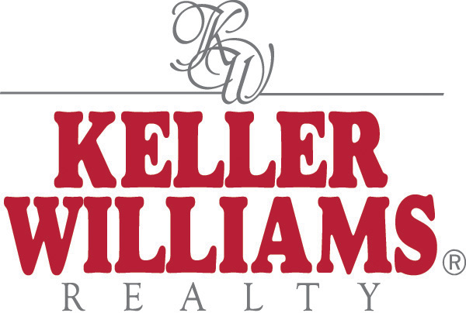

Galey Kotsher Group

Summary of Qualifications

The partners of Galey Kotsher Group (GKG) are uniquely qualified in the evaluation/analysis, marketing and sales of residential, commercial and land related properties--for financial institutions, builders, developers and investment groups. Keller Williams is the third largest realty company in the nation. With REO sales and service as a primary area of focus, GKG specializes in the Disposition of Troubled Assets, which includes all classes of residential dwelling units and commercial properties, as well as, raw and developed land collateral. Clients include some of the largest local and regional banks in the Mid-Atlantic area. GKG has collectively prepared over 1000 Broker Price Opinions on behalf of clients and successfully managed the sale and settlements of hundreds of REO related Collateral properties.

J. LARRY GALEY:

2007-Present: Galey Kotsher Real Estate Group/Principal and Associate Broker,
Keller Williams Team Realty, Rockville and Baltimore, MD. Evaluation, marketing and sales of properties throughout the mid-Atlantic states. Extensive experience in metro-Baltimore markets as well as Washington metro and MD eastern shore—marketing all classes of real estate for financial institutions, builders and developers.

2005-2007 JLG Realty Consultants, LLC, President, Potomac/Baltimore, Maryland, a Commercial and General Brokerage Realty concern licensed in Maryland, Virginia and West Virginia. JLG’s primary area of focus was the disposition of troubled assets on behalf of banks, FNMA and FREDDIE MAC. JLG also brokered over $100 million of land to builder/developers annually.

2003-2004: Greenvest/The Cambridge Company, Vienna, VA. Vice President of Sales and Marketing. Metro-Washington based homebuilder with annual sales of 200 units and volume of $80 million-- solely owned by Greenvest, LLC. Developments in Virginia, West Virginia and Maryland with a diversified product line including detached, attached

and condominium homes. Focused on preparing feasibility studies and competitive market analyses for land acquisition and project price positioning. Worked exclusively with lenders to secure project financing.

1993-2003: Porten Homes, Inc., Executive Vice President, Bethesda, MD.
Metro-Washington area based homebuilder also building in South Florida. Annual volume for sales revenues averages $80 million. Focused on mid-rise condominiums, single-family homes, town homes, and multi-family specialty products. Also specialized in in-fill developments involving creative land planning and product development. Prepared all feasibility studies and competitive market analyses for land acquisition and project price positioning. directed the opening of new home communities in Maryland and Virginia, devised and established reporting systems to builder clients and lending institutions.

1990-1993: Developers Marketing Inc., President, Bethesda and Baltimore, MD
A subsidiary of Robert Feldman and Associates, an established marketing and advertising firm specializing in residential and commercial real estate. Founded Developers Marketing Inc. to provide sales management services to small builders: preparation of market feasibility studies for land acquisition, competitive market analyses for product development and price positioning and reporting systems to builder clients.

1983-1990: Porten Sullivan Corp., Vice President Sales and Marketing, Bethesda, MD.
Top 10 Metro-Washington Builder/Developer with average yearly revenues in excess of $100 million on 500+ yearly sales. Directed the opening of over 50 residential communities in Maryland, Virginia and the District of Columbia, prepared feasibility studies and competitive market analyses for land acquisition and project price positioning, and established comprehensive reporting systems.

EDUCATION: B. S., Marketing, University of Maryland, College Park, Maryland.

PROFESSIONAL DEVELOPMENT/RECOGNITION:

-- Certified BPO/REO Specialist with RES.NET and trained and certified in the use of EQUATOR PRO BPO SOFTWARE
-- Advanced Real Estate Management NAHB (80 hours); Continuing Education in Real Estate, Maryland, Virginia and West Virginia Real Estate Commission (1000 hours). Guest lecturer NAHB Convention, Dallas, Licensed Broker, Maryland, Virginia and West Virginia.
--EQUATOR and BPO Software specialist..

PAUL S. KOTSHER

2007–Present: Galey Kotsher Real Estate Group/Principal, Keller Williams Team Realty, Rockville and Baltimore, MD. Evaluation, marketing and sales of properties throughout the mid-Atlantic states. Extensive experience in metro-Baltimore markets as well as Washington metro and MD eastern shore—marketing all classes of real estate for financial institutions, builders and developers.

2008/2009: DR Horton MD/DE Division, Vice President Sales and Marketing, Rockville, MD. Responsible for market analyses, gross profit objectives, marketing, sales and closings for nation’s largest home builder—representing 200 annual sales for a diverse product line including condominiums, townhomes, detached and multi-family.
Opened several new communities and focused on inventory reduction in declining market.

2006-2008: Grayson Development Co./Grayson Homes, Director of Land Acquisition/Sales , Ellicott City, MD. Managed acquisition activities including market research, pro formas and contract negotiations for thousands of lots throughout the Baltimore/Washington area—with specialization in redevelopment properties. Also managed sales department in 10 communities with focus on liquidating inventory during declining market.

2004-2006: Portrait-Pasquinelli Homes, Division Manager, Frederick, MD. Started mid-Atlantic division for nation’s largest private national homebuilder. Negotiated over 1,000 lots, (in coordination with JLG Realty Consultants secured largest residential land sale in West Virginia panhandle), in nine months in several states. Responsible for market analyses, pro formas/department budgets, staffing, marketing sales, construction, purchasing, and land development.

1991-2004: Pulte Homes, Vice President Sales and Marketing, Baltimore, MD Managed department responsible for all feasibility studies and market analyses for asset management committee, marketing, sales and gross profit/ROI objectives. Developments throughout MD and DE represented up to 700 units per year and up to 25 communities and annual revenue of up to $200 million. Also responsible for marketing Del Webb communities in Easton and Taneytown, MD.

1989-1990: The Patt Corporation, Vice President Residential Division, Managed residential division of PA based company, including competitive positioning of residential and commercial properties, marketing and sales in seven states. Managed sales for largest planned development community in New Jersey, (Smithville/Atlantic City). Also marketed shopping center, hotel, resort and personal care properties.

1981-1989: Porten Sullivan Corporation, Director of Sales and Marketing, Bethesda, MD. Co-directed sales and marketing of regional homebuilder in Maryland and Virginia with J. Larry Galey.

EDUCATION: B.A. in Communications, The American University, Washington, D.C.
M.S. in Business Communications, Emerson College, Boston, MA

PROFESSIONAL DEVELOPMENT/RECOGNITION

--Licensed in Maryland and Virginia.
-- 2009/2010 Board of Directors, Home Builders Association. of Maryland (HBAM)
--HBAM Chapter President, Carroll County 2009/2010
--Member: National Assn. of Realtors/MD Association of Realtors, Greater Baltimore Board of Realtors
--Experienced with BPO software and competitive market analysis tools

904 Wind River Blvd, Gaithersburg, Maryland 20878

