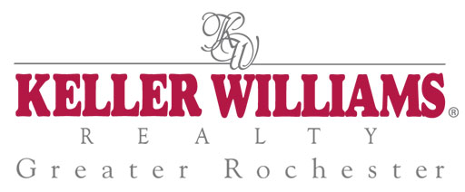
Keller Williams Realty

Superior Services Program
Seller Services Guarantee

How will we represent you Property Sign
Marketing Action Plan Advertising program
Competitive Pricing Information Written disclosure
Financing Alternatives Home warranty
Estimate of our proceeds Keeping you informed
Home enhancement plan Home finding process
Keller Williams Team Pre-qualified buyers
Other real estate professionals Negotiating on your behalf
Multiple Listing Service Closing the sale
Information on your property After-sale service
Direct promotion Evaluating our service

www.kw.com

