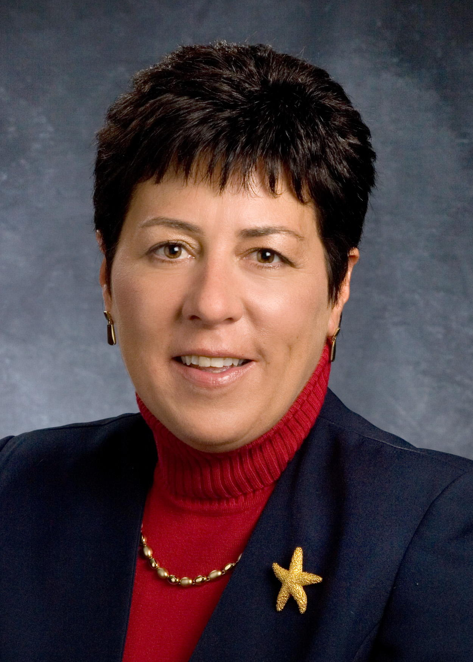
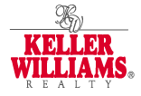

Mary Wenderlich 2000 Winton Road S.
Sales Associate Building #1 Suite 201
Work: 585-362-8979 Rochester, NY 14618
Cell: 585-233-5574
marywenderlich@kw.com

Mary’s Action Plan

My objectives for selling your home:

- Be proactive in getting as many qualified buyers as possible into your home until it is sold.

- Communicate to you the results of our activities on a weekly basis.

- Assist you in negotiating the highest dollar value between you and the buyer.

The following are PROACTIVE STEPS I will take to sell your home:

- Prepare a Market Analysis and assist you in determining how to best position your home in the market.

- With in 24 hours of signing a listing agreement, I will enter your home into the Greater Rochester Multiple Listing Service and market your home to other agents and realtors.

- Create and deliver a full-color brochure to all agents and prospective buyers.

- Installing a "FOR SALE" sign in your yard to attract drive-by traffic.

- Make suggestions and advise you about any changes you may want to make to make your property more marketable as well as assist in planning repair work to home if necessary.

- Provide you with a weekly detailed report of all factors that that affect the sale of your home. How many homes are on the market, how many sold in last 7 days, if someone did not buy your home why and what did they buy? Interest rates, how many showings, feed back from those showings. Etc.

- Advertise your home on the following websites:

- Homes.com  - Realtor.com  - Homesteadnet.com  - Craigslist.com  - DemocratandChronicle.com  - Postlets.com | - Trulia.com  - Yahoo.com  - Move.com  - Googlebase.com  - RealEstateShows.com

- Advertise in various publications such as:
- Property Source  - Democrat and Chronicle  - Harmon Homes | - Real Estate Book  - Penny Saver  - Shopping Bag
10. Alert Business affiliates, past clients, other active real estate agents, and your neighborhood of the features and benefits of your home.

11. Utilize homefeedback.com to provide you instant feedback of every showing from other agents and potential buyers.

12. Assist you in pricing your home competitively to open the market vs. narrowing the market.

13. Promote your home to all Keller Williams agents.

14. Prospect 3 hours daily speaking with 25-50 people looking potential buyers for your property.

15. Follow up on every lead within minutes of time received.

16. Represent you on all offer presentations to negotiate the best price and the best terms.

17. Utilize Real Estate Shows (Virtual Tours) to market your home which will attract more viewers and potential buyers to your listing.

18. Pre-qualify all buyers.

19. Handle all follow-up after contract is received such as the inspection, appraisal, mortgage application, mortgage commitment, final walk through and closing date.

20. Offer you 100% satisfaction guarantee.

