
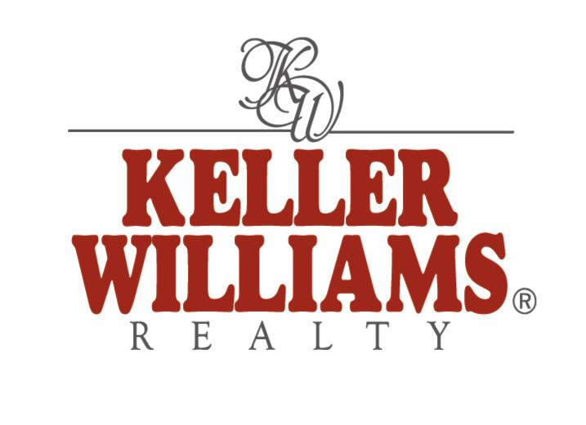
First Time Home Buyers
HAVE YOU BEEN THINKING ABOUT BUYING? . . . .
Putting Your Mind At Ease

Owning a home is a dream that has recently started becoming a reality for many people. But for many more, the maze of questions, hurdles and potential problems prevents them from taking the big step towards owning their first home. Thankfully, as independent, knowledgeable Southern Nevada real estate professional, Debra Pizzolato, makes buying your first home easy. With strong advice, marketplace knowledge, and the personal touch, Debra is on top of the Southern Nevada real estate market.

Debra Pizzolato can provide you with the answers you need to help guide you through the process of owning your first home, from offering you information about the best neighborhoods for schools, to suggesting the perfect restaurant, and even on ways to qualify for a good mortgage; she can and will give you all of the information you need, to ensure that your first home purchase is your happiest. With Rates & prices so low, now is the best time in History to buy a home in Southern Nevada!

A home is an investment. When you rent, you write your monthly check and that money is gone forever. But when you own your home, you can deduct the cost of your mortgage loan interest from your federal income taxes, and usually from your state taxes. This will save you a lot each year, because the interest you pay will make up most of your monthly payment for most of the years of your mortgage. You can also deduct the property taxes you pay as a homeowner. In addition, the value of your home may go up over the years. Finally, you'll enjoy having something that's all yours - a home where your own personal style will tell the world who you are.

Using a real estate agent is recommended. All the details involved in home buying, particularly the financial ones, can be mind-boggling. A good real estate professional can guide you through the entire process and make the experience much easier. As a Realtor I will help you figure the price range you can afford and search multiple listing services & various web-sites for homes you'll want to see. With immediate access to homes as soon as they're put on the market, the agent can save you hours of wasted driving-around time. When it's time to make an offer on a home, as your real estate agent, I can point out ways to structure your deal to save you money, as well as explain the advantages and disadvantages of different types of mortgages, guide you through the paperwork, walk you through every step of the process and answer last-minute questions when you sign the final papers at closing. And you don't have to pay me anything! The payment comes from the home seller - not from the buyer.

(There is a $500.00 transaction fee buyer charge that I personally waive for first time buyers, if the seller will not pay it at close of escrow!)

Common First Time Buyer Questions

How much home can we afford? Your ability to afford a home depends on a number of factors. You must consider your present income in light of your total financial picture. There are a number of mortgage calculators available for free on the Internet that can help you decide what you can qualify for, and what that will cost each month. (one site is www.realtor.com/search/mortgagecalculator.aspx?) It is important to note, however, that many of these don't factor in the costs of property taxes and homeowners insurance into your quote. These costs need to be considered as well, and as always, if in doubt, talk Debra Pizzolato.

How do I qualify for a mortgage? Qualifying for a mortgage is not the mystery it once was. With so many lending institutions available through the Internet, you may be more likely to qualify than you ever thought possible. The first step in qualifying for a mortgage is to talk to your lender. He or she will request some information about your current financial situation. You may have to provide paperwork related to your current employment status, and you will soon be notified of the lending institution's decision – generally within a few days. If you are interested in finding out whether or not you will qualify for a mortgage before you ever approach a lending institution, there are a few things you can do. First, determine what your debt to income ratio is. Most lending institutions think that your housing costs should only be 28% of your monthly income. Moreover, they tend to believe that your total monthly debt should not be more than 36% of your income. If you have more debt than most lenders will accept, it might be a good idea to take a hard look at eliminating some of your outstanding balances before you apply for a home loan. Once you've looked at your debt compared to your income, you should glance at a copy of your credit report (you can get this free or for a minimal charge through several online websites). Check it for errors, and look at your overall score – if it’s low, you might need to do some credit repair before you buy a home. Remember, lenders will look carefully at your past payment history, so if you've had some financial issues in the past, some lenders simply won't consider you for a mortgage – or they’ll give you excessive interest rates and terms. For advice on good local mortgage lender options and to find out how to improve your credit score, talk to Debra Pizzolato of Keller Williams.

How much money should I put down on my new home? The down payment on a new home is one of the scariest factors for most home buyers. The simple truth is, though, the down payment on a home shouldn't concern you. Lenders usually require at least a 20% down payment to qualify for a mortgage. Nowadays, most companies will allow you to get a mortgage loan with only a 3-5% down payment if you take out private mortgage insurance. If it is possible, though, there are a number of advantages to putting 20% down on your home. First, it gives you a strong amount of equity in your home at the start of your ownership. Second, you can avoid the costly private mortgage insurance with a higher down payment amount. Finally, the more money you are able to funnel into a down payment, the lower your house payments will be. Your overall decision about how much money to put down on your new home will be decided by your current financial state and your personal preferences. You will need money for closing costs too. However many sellers are willing to pay for all or part of buyers closing costs right now. If you’re unsure about your own situation, talk to Debra Pizzolato, Real Estate Consultant, for advice.

Can I buy a home with no down payment? In the last ten years, many lenders have come up with some fairly innovative mortgage programs that allow borrowers to purchase homes without down payment money. In this case, the lender finances 100% of the home's value. This can be a bit more dangerous for lenders and it has become a risk that most are not willing to take, especially in a market where home prices keep falling. There are a few drawbacks to purchasing a home in this manner. First, some banks will require you to purchase private mortgage insurance. This can be a bit costly, but there are other home loan programs available if you want to avoid it. Many lenders have piggyback loan programs. You borrow 80% of the home's value, then you take out a second mortgage for 20% of the value of the home. The interest on both loans is tax deductible. Currently these loans are hard to find and qualify for. There are several FHA home ownership programs that offer little (3.5%) or no down payment loans. You do have to pre-qualify for these kinds of loans, and there are some limitations, but they can be great programs for first time buyers. FHA is a good choice for first time buyers. If you are a veteran, the VA also offers no down payment loans. There are no out of pocket fees with this type of loan, but there are some restrictions. Some banks offer private programs you can look into if you cannot afford the down payment on a home.

Is it better to rent or buy? In general, owning a home is your best bet. When you write the check to a rental agency each month, your money is simply gone. When you write the check to a mortgage company each month, you are investing in something you will some day own. The value of your home may increase over time, making it an excellent financial investment. Moreover, most home payments are far less than the cost of rental payments, saving you a bit of money each month. While there may be some drawbacks to home ownership, like having to pay for the cost of repairing and maintaining the home, overall, it is a far better deal to purchase a property than to rent one.

Are there tax advantages to owning a home? There are a number of tax advantages to owning a home. The interest you pay on your home is deductible on your state and federal income tax forms. You may also be able to deduct the amount of your property taxes each year. Moreover, should you ever need to take a second mortgage loan out on your home (when the home has equity), the interest on that loan will be deductible as well. Currently, being a home owner and living in the property allows you to save on capital gains taxes when you sell for a profit (up to $500,000 per married couple and $250,000 per individual) as long as you live in the home 2 out of 5 years)!

Buying a home for the first time is an exciting process, but it can also be a bit overwhelming. Using real estate professionals like Debra Pizzolato, Realtor, of Keller Williams, can make your home buying process in Southern Nevada go much smoother. Have a trusted professional on your side when you buy your first home.
If you are interested in receiving more information on the buying process or perhaps would like a lender recommendation, please contact me at 702-348-8450, DebraPizzolato@Yahoo.com or visit me on the We @ www.TheVegasHomeSearch.com. As a local Real Estate Consultant, I focus my time on providing world-class service to my clients and building lifelong relationships.

Please feel comfortable referring me to your friends, family, associates or anyone you come across that wants to buy, sell, needs real estate help or information on Foreclosure, Short Sale, or 1031 Exchange. You can expect that they will receive the highest level of commitment, confidentiality and service, I am here to help!

Debra Pizzolato, Realtor®
702-348-8350 Direct
702-456-1099 Fax
www.TheVegasHomeSearch.com
DebraPizzolato@Yahoo.com
2230 Corporate Circle Suite # 250
Henderson, NV 89074

Professional Advice & Friendly, Trustworthy Service

