FIRST AMERICAN TITLE COMPANY

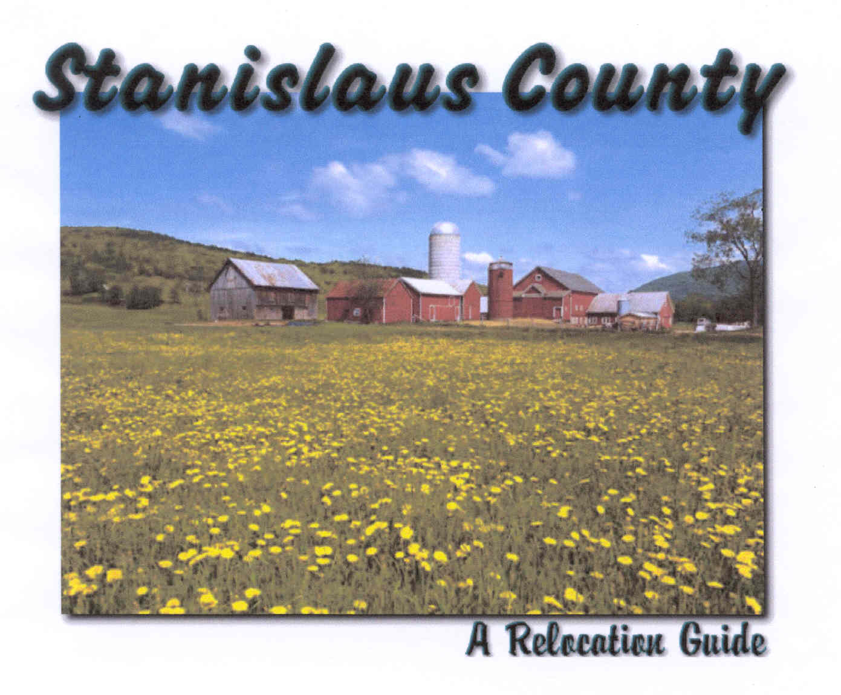

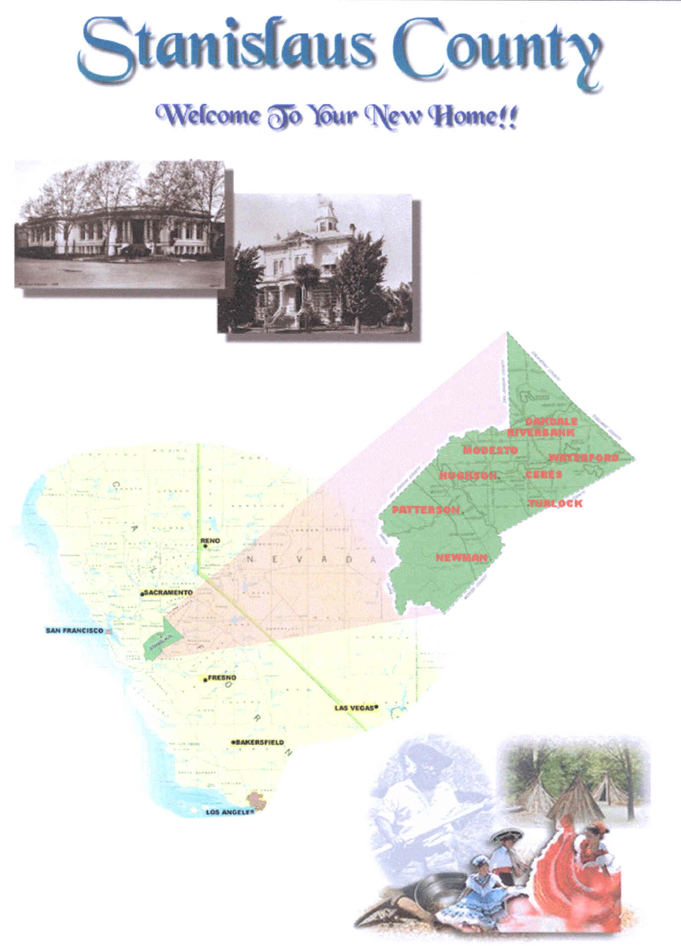

This is Stanislaus County

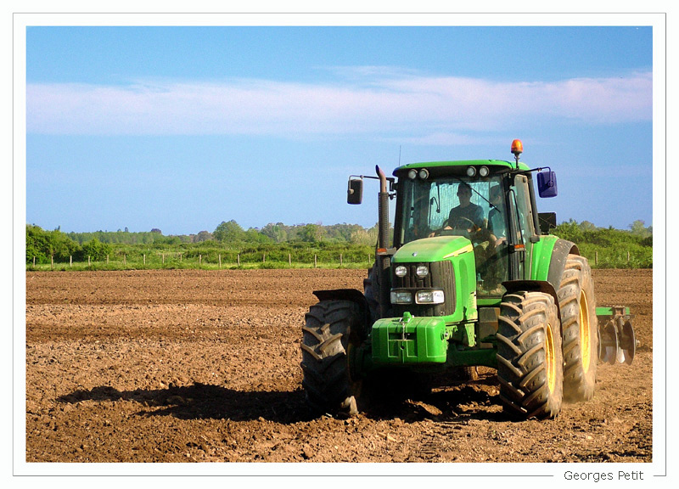

Stanislaus County is a county located in the Central Valley of the U.S. state of California, between Stockton and Fresno. As the price of housing increases in the San Francisco Bay Area, many commuters have moved to Stanislaus County. As of 2000 the population was 446,997.

Population Trends
1980 1990 1995 1997 1999

County Pop. 265,902 370,522 411,300 421,900 433,000

History

Stanislaus County was formed from part of Tuolumne County in 1854. The county is named for the Stanislaus River, first discovered by Gabriel Moraga in 1806, and later renamed Rio Estanislao in honor of Estanislao, a mission-educated renegade Native American chief who led a band of Indians in a series of battles against Mexican troops until finally being defeated by General Mariano Vallejo in 1826. Estanislao was his baptismal name, the Spanish rendition of Stanislaus, itself the Latin rendition of the name of an 11th century Catholic saint from Poland, St. Stanislaw.

Geography & Environment

According to the U.S. Census Bureau, the county has a total area of 3,923 km² (1,515 mi²). 3,869 km² (1,494 mi²) of it is land and 54 km² (21 mi²) of it (1.38%) is water. There are a number of rare and endangered species that are found in Stanislaus County. The Beaked Clarkia, (Clarkia rostrata) is listed as a candidate for the Federal Endangered Species List. It has only been found in blue oak-digger pine associations in the foothills of the Sierra Nevada, a habitat which occurs at moderately high elevations. Colusa Grass, (Neostapfsia colusana) is listed as endangered by the State. It is restricted to vernal pools. (Torrey, 1989)

Major Highways
- Interstate 5
- California State Route 4
- California State Route 33
- California State Route 99
- California State Route 108
- California State Route 120
- California State Route 132

Demographics
As of the census of 2000, there were 446,997 people, 145,146 households, and 109,585 families residing in the county. The population density was 116/km² (299/mi²). There were 150,807 housing units at an average density of 39/km² (101/mi²). The racial makeup of the county was 69.33% White, 2.58% Black or African American, 1.27% Native American, 4.22% Asian, 0.34% Pacific Islander, 16.82% from other races, and 5.44% from two or more races. 31.74% of the populations were Hispanic or Latino.
There were 145,146 households out of which 41.20% had children under the age of 18 living with them, 56.00% were married couples living together, 13.70% had a female householder with no husband present, and 24.50% were non-families. 19.40% of all households were made up of individuals and 7.90% had someone living alone who was 65 years of age or older. The average household size was 3.03 and the average family size was 3.47.
In the county the population was spread out with 31.10% under the age of 18, 9.80% from 18 to 24, 29.00% from 25 to 44, 19.50% from 45 to 64, and 10.40% who were 65 years of age or older. The median age was 32 years. For every 100 females there were 96.80 males. For every 100 females age 18 and over, there were 93.40 males.
The median income for a household in the county was $40,101, and the median income for a family was $44,703. Males had a median income of $36,969 versus $26,595 for females. The per capita income for the county was $16,913. About 12.30% of families and 16.00% of the population were below the poverty line, including 20.50% of those under age 18 and 8.80% of those ages 65 or over.

Economy
Agriculture is Stanislaus County's number one industry.
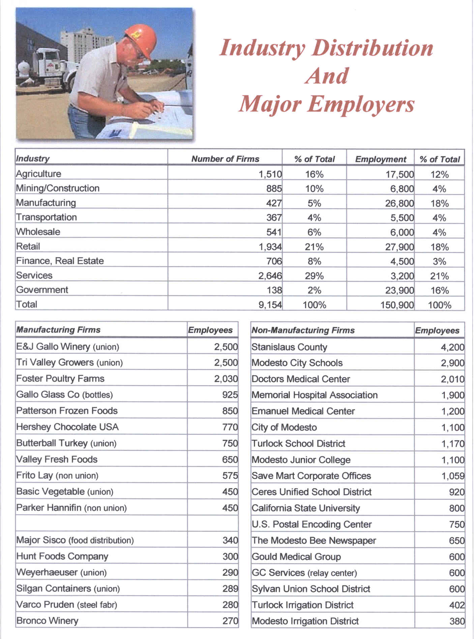

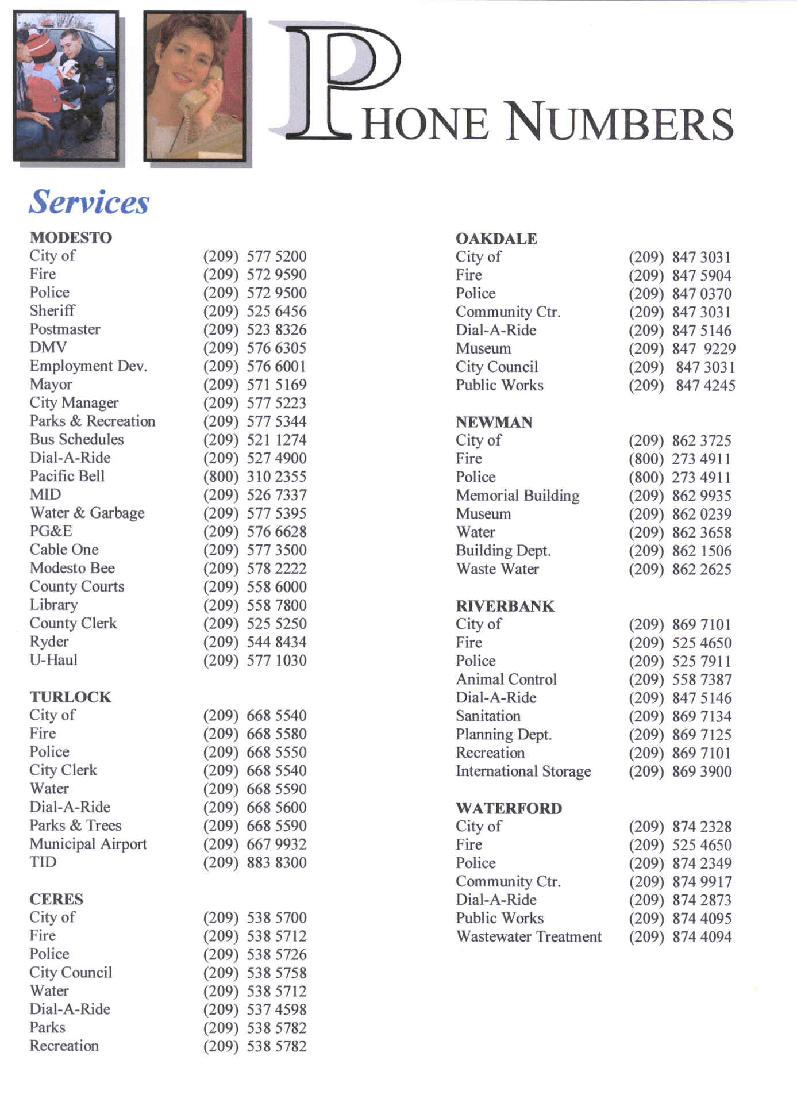

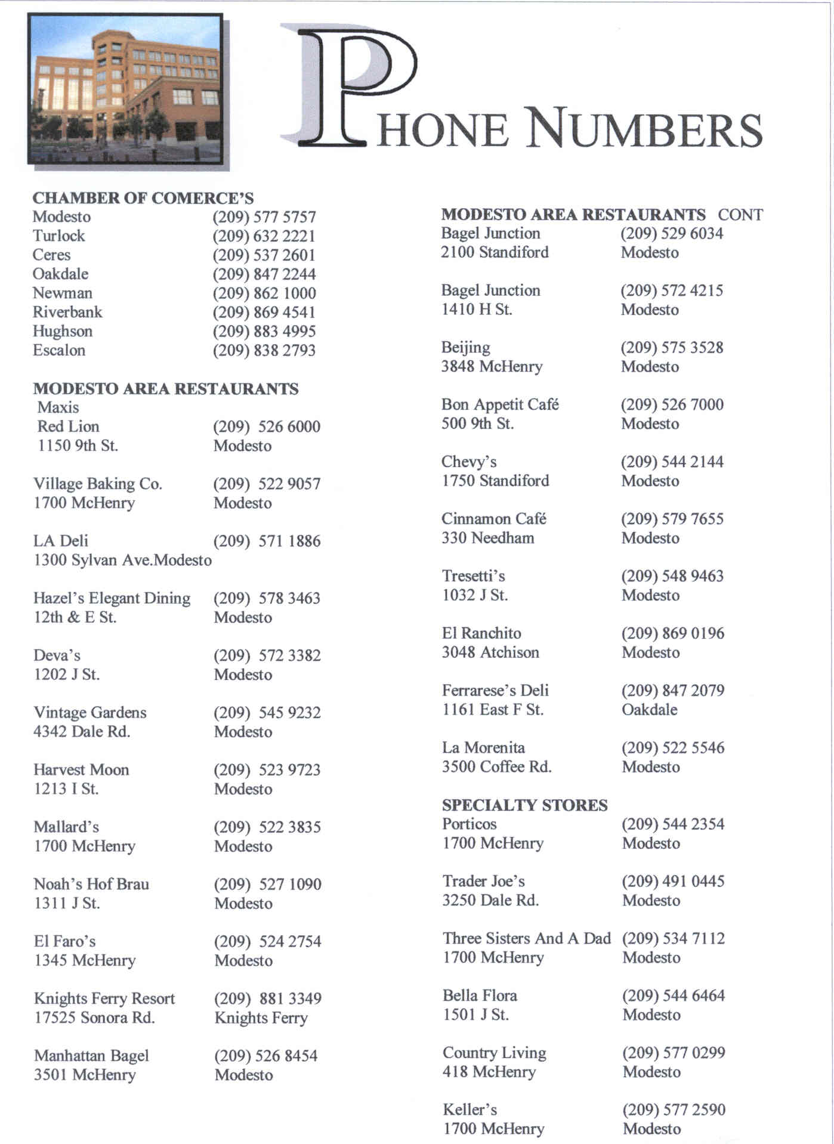

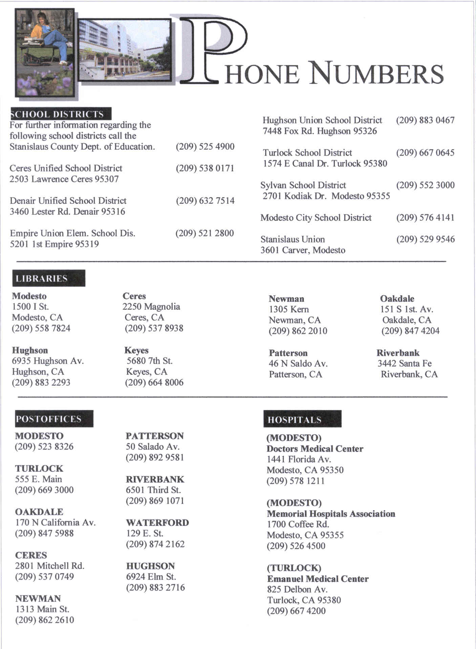



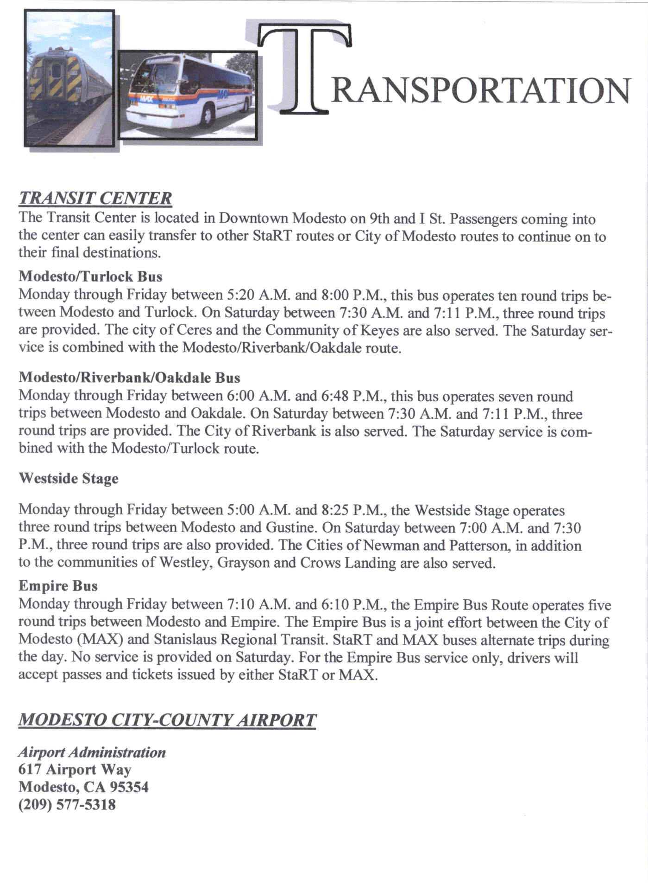

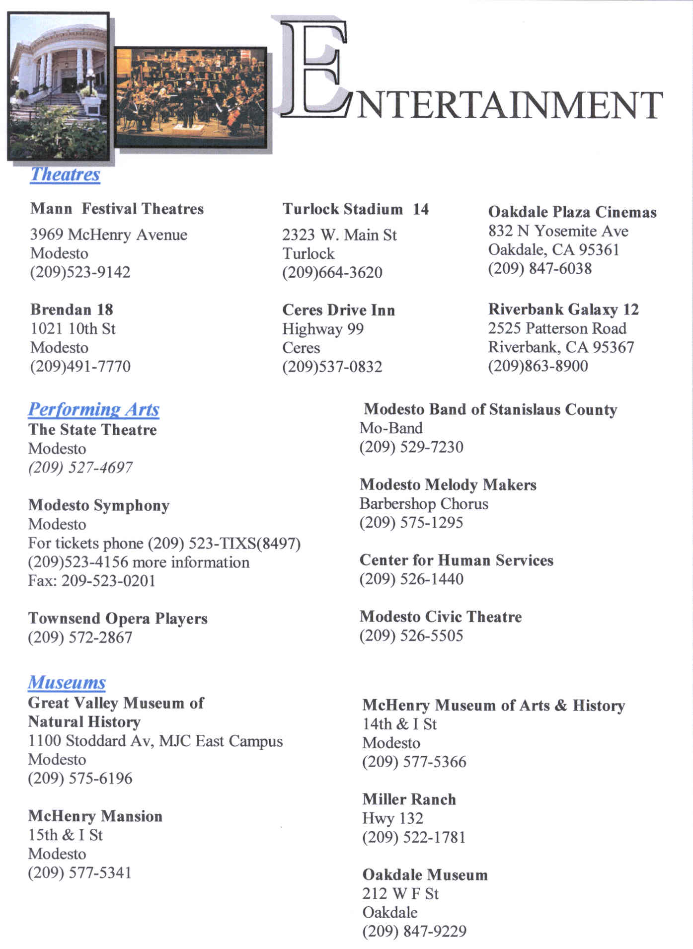

 Things to Do

Modesto Nuts Baseball Modesto Reservoir
The Modesto Nuts play a 874-9540
70-game home schedule
from April through September

Boomers Lake Tulloch
4215 Bangs Ave. 545-4166 800-894-CAMP

Discovery Zone New Hogan Reservoir
3500 Sisk Rd. 545-7529 772-1343

Funworks Family Fun Center New Malones Reservoir
Corner of Coffee and Clarentina 785-3300 or 536-9094
578-4FUN

Laser Quest Turlock Lake
2100 Standiford Ave, 526-0000 800-894-CAMP

Paintball Central Woodward Reservoir
3120 Oakdale Rd. 551-0103 874-3304

Camanchie Reservoir Lake Don Pedro
763-5178 or 763-5121 852-2396

Lake McClure Lake McSwain
378-2521 800-468-8889



