

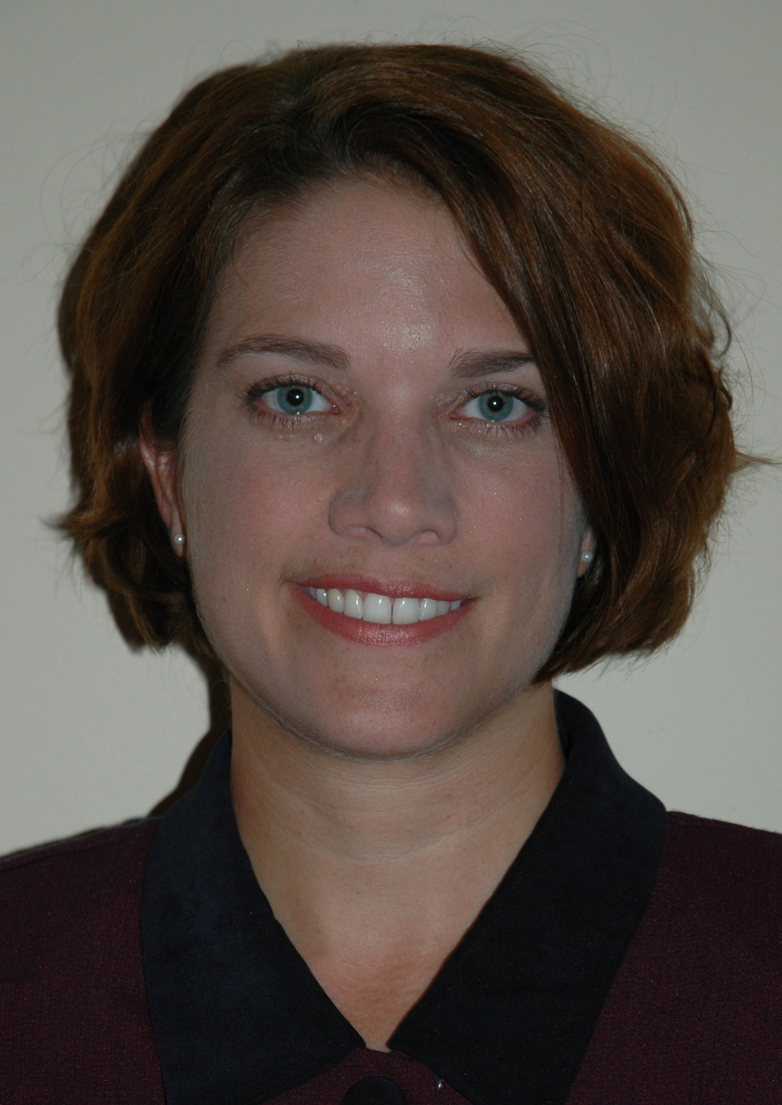




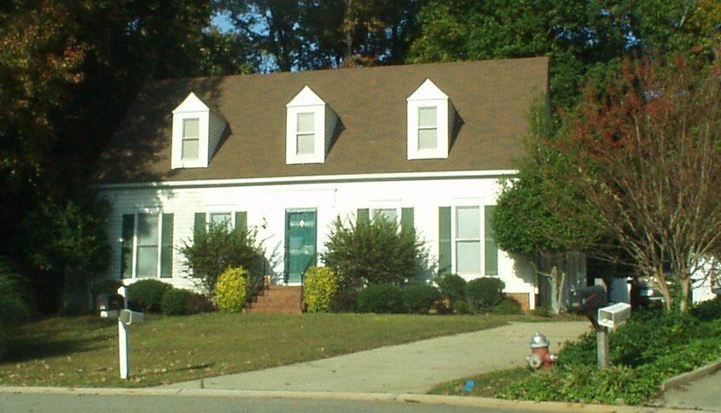

Don’t pay the minimum on an option ARM. An option ARM is an adjustable-rate mortgage that lets you decide how much you pay each month….when you make the minimum payment on an option ARM you owe more on your house the next month.
When you get a mortgage, shop around. First, shop the Internet for rates, but look for a local lender to apply for your loan.
(adapted from article on Bankrate.com, author: Holden Lewis, for the full length article e-mail: twallace10@sc.rr.com)
Whether you already have a mortgage or you plan to buy a house in the next year, here are seven mortgage tips for 2007:
Review your mortgage—does it still fit your circumstances? Life events can trigger changes in the way you pay for your house. Before refinancing to save money, make sure you won’t get zapped with a prepayment penalty, either when you refinance or sell the house.
Watch out for reset. The rate adjustment on an Adjustable Rate Mortgage is called the “reset”, and on hybrids such as 3/1 and 5/1 ARMs a lot of borrows will face jumps of 3% - 3.5% in 2007 (some will face up to 5%!). Don’t get caught by surprise by a rate reset. Refinance the loan if it makes sense to do that.

Make an extra payment. If you make 13 mortgage payments every year, you will pay off a 30-year, fixed-rate mortgage in less than 25 years.
Think about getting mortgage insurance instead of a piggyback loan. If you buy a house in 2007, and you make a down payment of less than 20 %, you’ll either have to buy mortgage insurance or get a piggyback loan. A new tax law for loans originated in 2007 allow the mortgage insurance premiums to be deducted from federal income tax. This is an important change because it means that mortgage insurance will be cheaper in the long run for a lot of home buyers, especially those who live in their homes for five or more years and keep the same mortgage.
Be skeptical. If it sounds too good to be true, it probably is.
1535-D Broad River Road
Columbia, SC 29210

Phone: 803-397-4996
Fax: 866-788-4941
E-mail: twallace10@sc.rr.com
Tracey L. Wallace
Realtor®
Money Matters: 7 Smart Mortgage Moves for ‘07
Expect great things!
I’m on the web!
www.traceywallace.com

FEATURED PROPERTY
316 Cranewater Drive
(Irmo Area)
This is a one-of-a kind home with great curb appeal! 5 Bedroom/3 Bath, Extra large bonus room easily 6th Bedroom! 2383 Sq.Ft. Large private fenced back yard. Located at the end of a quiet cul-de-sac in Braewick subdivision. Irmo Schools.
If you, or a friend, would like more information on this home, or if you would like to preview this home call me today!

