

Information PACKET

Prepared For:

Upper East side
Houses that did not sell…

Miami, FL 33138

By
Augusta “Gigi” Krop – Realtor with a Heart
Direct Line: 305-710-2538
Augusta “Gigi” Krop - Realtor with a Heart
My 10+ Customer Service Commitment

As the REALTOR® you have chosen to exclusively represent you in the
purchase of your new home, I promise that I will:

- Provide you with 10+ Customer Service during the entire selling process including, taking the time to understand your wants, needs and expectations, returning your calls and emails the same day and being honest with you at all times.
- Help you obtain the highest possible price for your house in the shortest amount of time.
- Advise you on pricing and assist you with staging your home.
- Implement the 10 Point Marketing Plan to market your house through as many channels as possible.
- Coordinate the home showing process.
- Present all offers in person and advise you on the terms and contingencies.
- Negotiate offers on your behalf.
- Schedule and coordinate completion of contingencies and inspections.
- Monitor the buyer’s loan process.
- Coordinate and supervise the preparation of all closing documents and guide you through the closing process.

I look forward to selling your property!

Augusta “Gigi” Krop – Realtor with a Heart

So Many Decisions

There is so much to think about when selling your home:
- Is it a buyers’ market or a sellers’ market?
- How can I price my home so that it sells quickly?
- What marketing strategies are effective and will sell my home quickly?
- What’s this thing called “curb appeal?”
- What should I do to have my home in top-selling condition?
- How much should I fix? How much should I leave as-is?
- How much of a hassle is involved in showing my home?
- Should I try to sell my home all by myself? Or should I use an agent?
- What about all the paperwork and legalities?
- What about my next home? Should I buy or rent?
- And more!

I Can Help!
I am more than happy to answer any of your questions. Please put a check ☑ next to any of the above that you want to discuss.

Augusta “Gigi” Krop – Realtor with a Heart

Benefits of Using an Agent

Time is Money
How much is your time worth $________ per hour? If you don’t use a real estate professional, expect to spend at least 100 hours selling your home – assuming there are no problems! Considering your work, family, and personal commitments, is that the best use of your time?

Live & Work Near By
I live and work 5 minutes from your property which allows me to respond immediately to Buyers and Realtors that call from my sign or request last minute appointments. In order to show your house to its best advantage, I personally escort all Buyers and Realtors around your property and describe the benefits of the home and neighborhood. As your area expert, I am able to discuss all improvements that the village is planning on enacting, talk about the celebrities and interesting people that live in the area and discuss the convenience of the location. Other Realtors in the neighborhood know my name and enjoy working with me.

I Can Help!
My goal is to give you a 10+ experience!
What Benefits I provide to you: | Because…
- Consult with you on how to get your home in top-selling condition. | We want to WOW prospective buyers during the first 30 days that your home is on the market.
- Give you up-to-date information on what’s happening in the real estate marketplace. | Having up-to-date market information helps us strategize.
- Provide you with information on competing properties; e.g. list price versus actual SOLD price, financing terms, condition and more. | The fair market value of your home is determined by what competing properties are selling for right now.
- Market your home to other real estate agents and the public using research-based marketing strategies. | There is a misconception that advertising sells real estate. Research conducted by the National Association of REALTORS® shows that 41% of homebuyers first learned about the home they purchased from an agent; only 7% from a newspaper ad.
- Help you objectively evaluate and negotiate every buyer’s offer without compromising your position. | An offer is just the beginning of a process of appraisals, inspections and financing – a lot of possible pitfalls. I can help you write a legally binding win-win contract that is more likely to make it through the process.
- Help you close on the sale of your home. | The paperwork alone is overwhelming and it is not unusual for questions or unexpected problems to occur during closing (settlement).

Augusta “Gigi” Krop - Realtor with a Heart

Seven Real Estate Truths
Having an agent represent you has its advantages:
Professional representation… I am your personal representative and I’m required by law to represent your best interests to the best of my ability.
Personal specialist… it’s similar to hiring an accountant to help you file income taxes or a mechanic to fix your car. If you had the time to master those specialties, you would be doing your own taxes and fixing your car. But who has that sort of time? Besides, most people will sell only two homes in their lifetime – two real estate transactions in a lifetime will not turn anyone into a real estate specialist.
Objectivity… my job is to point out all the pros and cons for all the decisions you will be making throughout the home-selling process. I will even tell you things you may not want to hear because as your agent, I want you to make informed decisions, not emotionally-based decisions.
Convenience… these days, it’s nearly impossible to sell a home all by yourself without it turning into a part-time job.

- Not all real estate professionals are REALTORS®. Only licensed real estate agents who are members of the National Association of REALTORS® can call themselves REALTORS®. REALTORS® are committed to treat all parties honestly – they subscribe to a strict code of conduct and are required to maintain a high level of real estate standards. It is to your advantage to work with a REALTOR® because of the training and standards this professional designation requires.

- The price of your home should be based on the price of sold properties in your area rather than the list price of properties now on the market – this is how we establish your home’s fair market value.
If it’s priced OVER its fair market value it will…
- Not attract as many buyers because they’ll think it’s out of their price range.
- Take longer to sell.
- Make competing properties look good.
- Become “shopworn.”
- Be overpriced in everyone’s minds (agents and buyers) and they tend not to forget.
- Cause you to lose valuable time and miss out on buying your dream home.
- Cause advertising dollars and marketing efforts to be wasted.
- Cause negotiations to stall.
- Cause appraisal problems.
- End up selling below market value in order to make up for all of the above.

- Research conducted by the National Association of REALTORS® shows that more buyers purchase their properties at fair market value – not above it. The percentage of buyers increases even more when the price drops below fair market value.
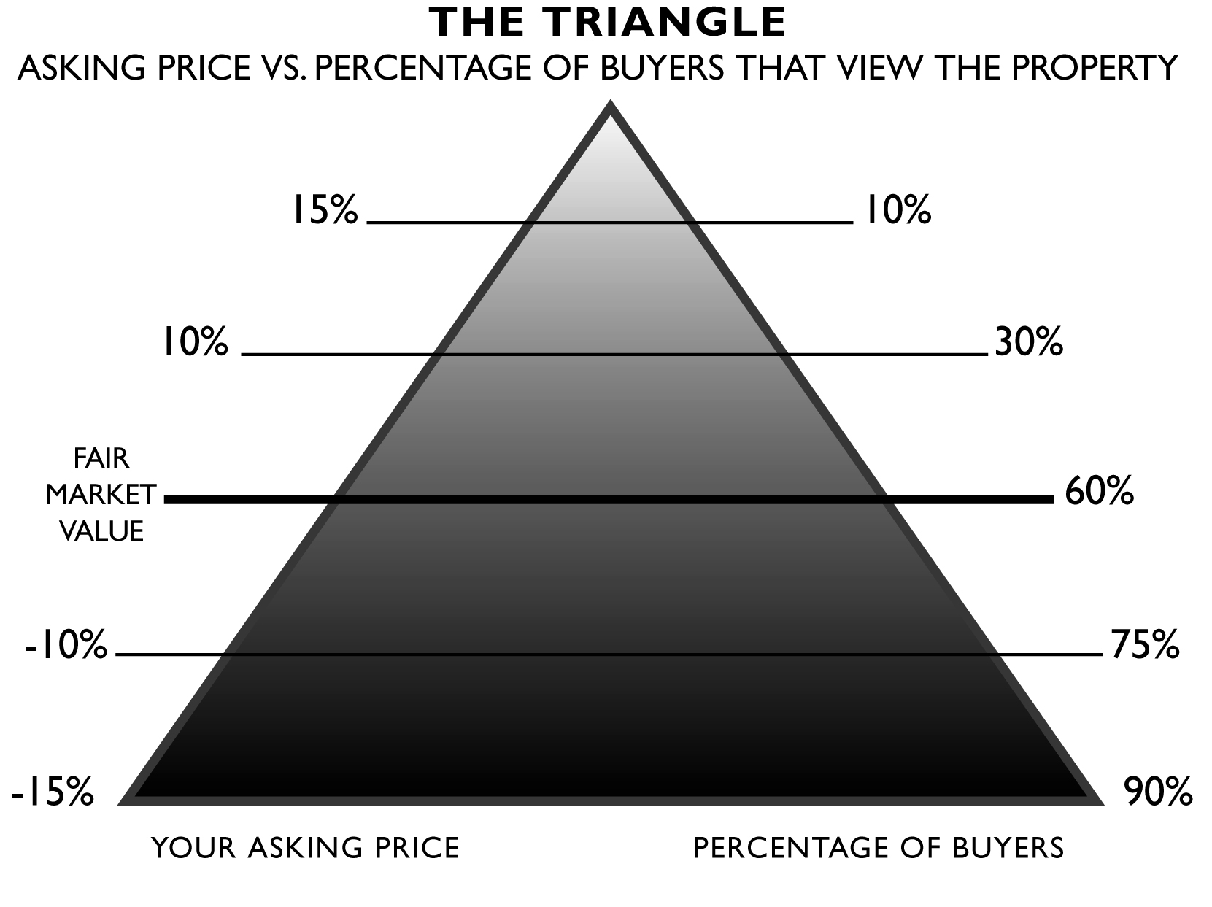

- The fair market value of your home is determined by the market – that is, what today’s buyers are willing to pay. Buyers are comparing your home to other homes now on the market. They don’t care about:
What You Paid
What You Need
What Another Agent Says
What It Costs to Build Today
What Your Neighbor Says
What You Want
What You Spent on Remodeling
What You Spent on Repairs
What You Spent on New Carpet
What You Spent on Upgrades

- Your home generates the most interest in the real estate community and among potential buyers during the first 30 days it is on the market. If it is not properly priced during this time, we miss out on this peak level of interest:
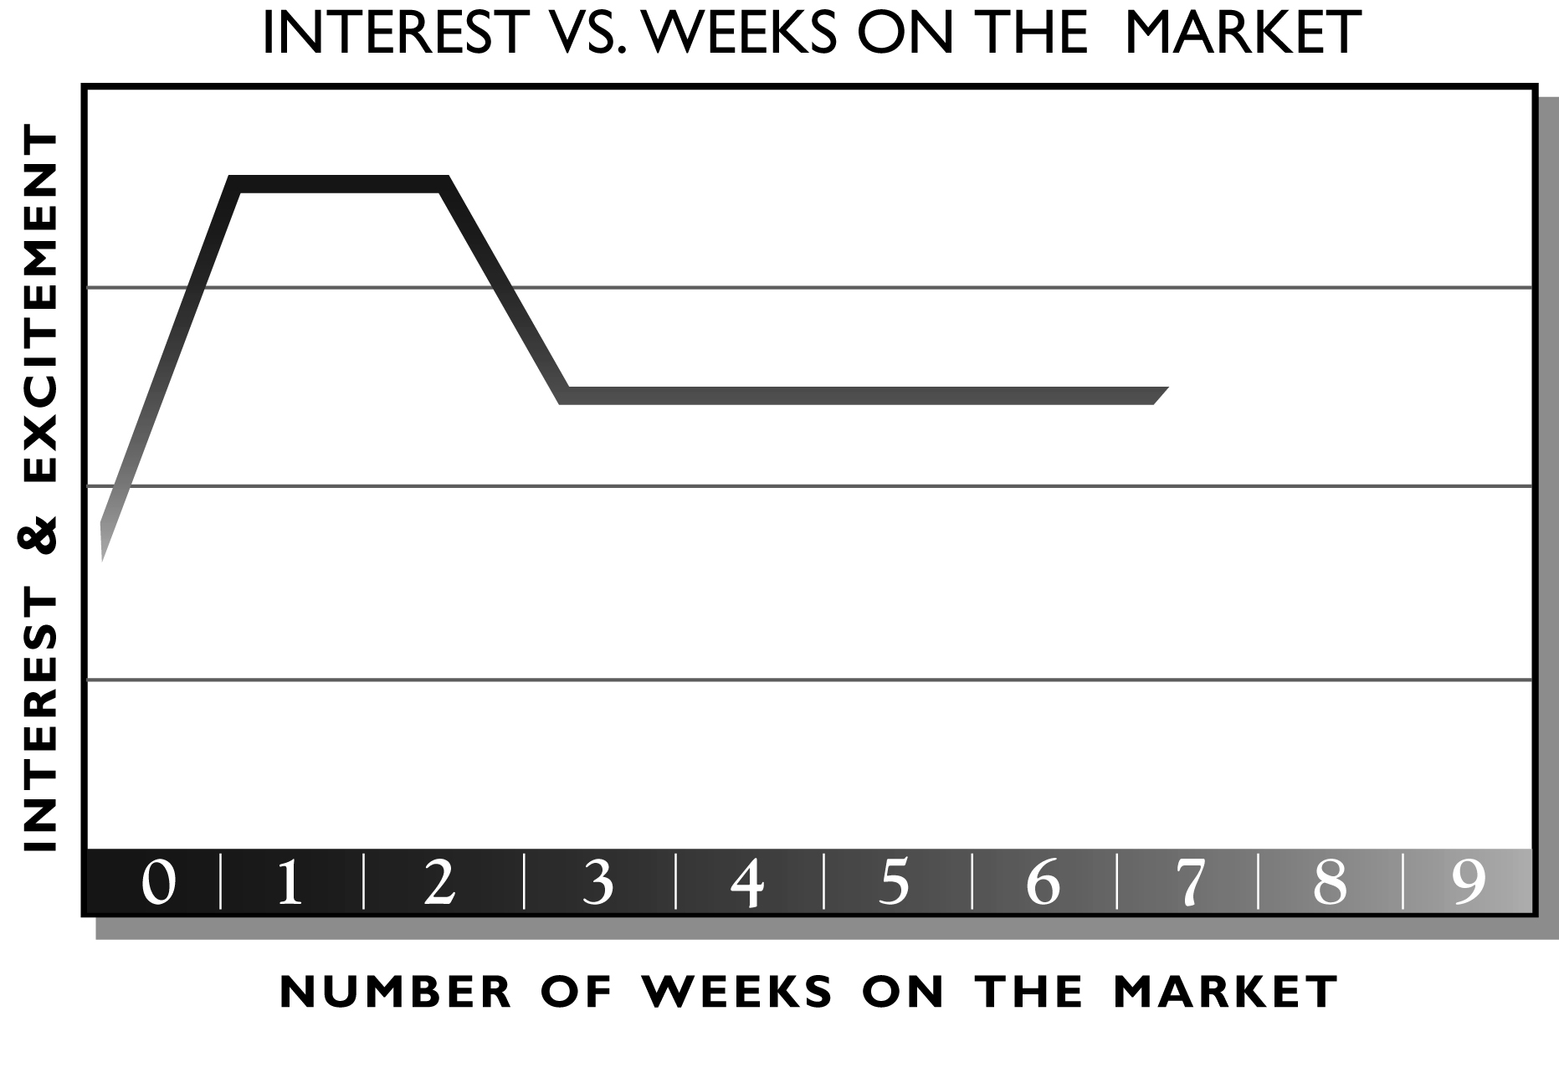
- Ads are not very effective for selling real estate. Data compiled in 2003 by the National Association of REALTORS® showed that buyers first learned about the home they purchased from:
Real estate agent | 41% | Builder | 7%
Yard sign | 16% | Knew the seller | 4%
Internet | 11% | Home book or magazine | 1%
Newspaper ad | 7% | Other | 6%
Friend, relative, or neighbor | 7%

Augusta “Gigi Krop – Realtor with a Heart
Ten Steps to Selling Your Home

- Define your goals, wants, needs and expectations. A good place to begin is by exploring your short and long term goals in life and how selling your home fits in. I will walk through a process I use to thoroughly understand my client’s goals, wants and needs to ensure that your expectations are met.
- Determine the best price for what’s going on in the market right now. We assess the current state of the market and what comparable homes are actually selling for by reviewing a Comparative Market Analysis (CMA) on your home. That way, we can objectively determine its fair market value and price it right.
- Prepare your property so that it is in top-selling condition. Most of us don’t keep our homes in top-selling condition. I will work with you to help you see things from a buyer’s point of view. I will consult with you on what to repair, replace or remove so that your home makes a GREAT first impression.

- Implement time-proven, research-based marketing strategies. Your home will be marketed with a 10 point marketing plan that has the highest potential for bringing not only the most buyers, but also the most qualified buyers to your doorstep.

- Show your property. Always keep your home in top-selling condition. When you leave for work, make sure that your home remains in top-selling condition. You know what they say about first impressions!

- Receive an offer. When a buyer decides to buy your home, an offer will be presented. I will advise you on the offer and whether the buyer is qualified to purchase your home.

- Negotiate to sell. Most offers require some level of negotiation. We will work together to decide your parameter and I will negotiate on your behalf.

- Have your home appraised and inspected. Once you have accepted an offer, I will work with the buyer’s agent to coordinate an appraisal, inspections and a survey (if required). If the buyer requires that certain repairs be made on your home, I will continue to negotiate on your behalf and recommend vendors so we move successfully from contract to closing.

- Prepare for closing. A few days before closing (also known as settlement), I will contact the title company and the buyer’s agent to ensure that all the necessary forms and documents have been prepared. I will meet with you to review the closing documents and let you know what additional forms and information you need to bring to the closing meeting.

- Close! At the closing meeting, ownership of your property is legally transferred to the buyer. I will be present to advise you and ensure that everything goes according to plan.

Augusta “Gigi” Krop – Realtor with a Heart
10+ Point Marketing Plan

- Staging – a beautiful interior décor and curb appeal is needed to target the hi-end Buyer… the Wow factor.
- Pricing strategies – Very important to address the current market situation.
- For Sale Sign, Rider Signs, and Directional Signs
- Box with Flyers and Distribution of Flyers in Neighborhood
- Flyers in House- Sign In Book
- MLS- My Colorful & detailed descriptions combined with hi-quality photographs get the attention of other Realtors and result in many showings –more showings means that the house sells quickly.
- Web Listings – Featured Property status on my web site:www.gigiwithaheart.com, Realtor.com – includes a package of several popular sites. Reference to my new blog on miamire.com.
- Open House Program – An Open House every Saturday and/or Sunday until it sells
- Track Showings/Collect Feedback
- Weekly Seller Updates
- Property Caravans & Catered Broker’s Open House
- Special Events

Optional Points:
- Email Broadcast to all KW Realtors and other R.E. offices
- Target Marketing to my data base
- Target Mailings to the area
- Hire a Professional to take aerial photos of waterfront homes

Keller Williams Realty
Augusta “Gigi” Krop – Realtor with a Heart
Keller Williams was founded in 1983, when most real estate companies were going out of business. Today, there are 400+ offices in the United States and Canada – and we’re still growing! There are 140 Realtors in my office and we work together to sell each others listings because we have a profit sharing plan. At Keller Williams, our culture is important. Our core beliefs are based upon WI4C2T.
 | Our Belief | Your Benefit
W | Win-win…or no deal. | You will get the best possible price in the shortest possible amount of time.
I | Integrity…do the right thing. | You are represented by an agent who is ethical at all times.
C | Commitment…in all things. | You have an agent who keeps all promises to give you a 10+ experience in selling your home.
C | Communication…seek first to understand. | Before we implement any marketing strategies or enter into any agreements, your wants and needs will be thoroughly analyzed.
C | Creativity…ideas before results. | Your house will be marketed using a creative 10 Point Marketing Plan.
C | Customers…always come first. | You are pledged a 10+ Customer Service Commitment that promises an exceptional experience.
T | Teamwork…together everyone achieves more. | We will work together to decide the best strategies for selling your home for the best possible price, in the shortest amount of time.
T | Trust…starts with honesty. | You are represented by an agent who is honest with you at all times.
S | Success…results through people. | At Keller Williams, our offices support each other. For you, this ensures a smooth transaction.




We are led by these visionaries:

Gary Keller
Co-Founder

“We believe we have found the essential formula for success in the real estate industry.”

Mo Anderson
Chief Executive Officer

“At the center of all our platforms is one thing – the consumer.”

Mark Willis
President

“When you help others succeed, you succeed. It’s all about creating a win-win for your clients and team.”
Dave Jenks
Keller Williams University Dean

“It’s truth…it’s doing the right thing…it’s impacting other people’s lives.”

Augusta “Gigi” Krop – Realtor with a Heart - www.gigiwithaheart.com
About Me

Family | Occupation
- As a single woman with no children (except for my cat) I am able to focus my attention on my real estate career and the needs of my customers. I am able to devote extra time to the details of finding, selling, marketing and closing the sales and purchases of your home.  - My degree in graphic design from Univ. of Miami combined with my photographic and marketing skills enables me to create special brochures and to publish beautiful descriptions & photos on the MLS | - I have my real estate license in Florida for over 14 years and am a certified Real Estate Paralegal for over 20 years. My real estate experience also includes building management, development and construction.  - The combination of my real estate paralegal knowledge and enjoyment of people made real estate and easy choice.  - Keller Williams Realty is my company of choice because of the profit sharing opportunities and the customer service philosophy.  - Top Producer at Keller Williams
Recreation | Dreams
- During my leisure I enjoy going out to dinner, the movies, concerts and sporting events. My other interests are photography, copywriting and graphic design.  - I am a member of the National Association of Realtors, the Realtor Association of Greater Miami and the Beaches, the National Association of Paralegals, The Writer’s Association of South Florida. | - Whether in life or in business, my goal is to treat all people with respect, understanding and equality.  - Since I am a Published Writer and Realtor with a Heart, I would like to write a novel and/or screenplay about a Realtor that is published and/or made into a movie.

Augusta “Gigi” Krop – Realtor with a Heart

Real Estate Glossary

Acceptance: the date when both parties, seller and buyer, have agreed to and completed signing and/or initialing the contract.

Adjustable Rate Mortgage: a mortgage that permits the lender to adjust the mortgage's interest rate periodically on the basis of changes in a specified index. Interest rates may move up or down, as market conditions change.

Amortized Loan: a loan that is paid in equal installments during its term.

Appraisal: an estimate of real estate value, usually issued to standards of FHA, VA and FHMA. Recent comparable sales in the neighborhood is the most important factor in determining value

Appreciation: an increase in the value of a property due to changes in market conditions or other causes. The opposite of depreciation.

Assumable Mortgage: purchaser takes ownership to real estate encumbered by an existing mortgage and assumes responsibility as the guarantor for the unpaid balance of the mortgage.

Bill of Sale: document used to transfer title (ownership) of PERSONAL property.

Cloud on Title: any condition that affects the clear title to real property.

Consideration: anything of value to induce another to enter into a contract, i.e., money, services, a promise.

Deed: a written instrument, which when properly executed and delivered, conveys title to real property.

Discount Points: a loan fee charged by a lender of FHA, VA or conventional loans to increase the yield on the investment. One point = 1% of the loan amount.

Easement: the right to use the land of another.

Encumbrance: anything that burdens (limits) the title to property, such as a lien, easement, or restriction of any kind.

Equity: the value of real estate over and above the liens against it. It is obtained by subtracting the total liens from the value.

Escrow Payment: that portion of a mortgagor’s monthly payment held in trust by the lender to pay for taxes, hazard insurance and other items as they become due.

Pre-Listing Packet

Real Estate Glossary (continued)

Fannie Mae: nickname for Federal National Mortgage Corporation (FNMA), a tax-paying corporation created by congress to support the secondary mortgages insured by FHA or guaranteed by VA, as well as conventional loans.

Federal Housing Administration (FHA): an agency of the U.S. Department of Housing and Urban Development (HUD). Its main activity is the insuring of residential mortgage loans made by private lenders. The FHA sets standards for construction and underwriting but does not lend money or plan or construct housing.

FHA Insured Mortgage: a mortgage under which the Federal Housing Administration insures loans made, according to its regulations.

Fixed Rate Mortgage: a loan that fixes the interest rate at a prescribed rate for the duration of the loan.

Foreclosure: procedure whereby property pledged as security for a debt is sold to pay the debt in the event of default.

Freddie Mac: nickname for Federal Home Loan Mortgage Corporation (FHLMC), a federally controlled and operated corporation to support the secondary mortgage market. It purchases and sells residential conventional home mortgages.

Graduated Payment Mortgage: any loan where the borrower pays a portion of the interest due each month during the first few years of the loan. The payment increases gradually during the first few years to the amount necessary to fully amortize the loan during its life.

Lease Purchase Agreement: buyer makes a deposit for future purchases of a property with the right to lease property in the interim.

Lease with Option: a contract, which gives one the right to lease property at a certain sum with the option to purchase at a future date.

Loan to Value Ratio (LTV): the ratio of the mortgage loan principal (amount borrowed) to the property’s appraised value (selling price). Example – on a $100,000 home, with a mortgage loan principal of $80,000 the loan to value ratio is 80%.

Mortgage: a legal document that pledges a property to the lender as security for payment of a debt.

Mortgage Insurance Premium (MIP): the amount paid by a mortgagor for mortgage insurance. This insurance protects the investor from possible loss in the event of a borrower’s default on a loan.

Pre-Listing Packet

Real Estate Glossary (continued)

Note: a written promise to pay a certain amount of money.

Origination Fee: a fee paid to a lender for services provided when granting a loan, usually a percentage of the face amount of the loan.

Private Mortgage Insurance (PMI): see Mortgage Insurance Premium.

Second Mortgage / Second Deed of Trust / Junior Mortgage / Junior Lien: an additional loan imposed on a property with a first mortgage. Generally, a higher interest rate and shorter term than a “first” mortgage.

Settlement Statement (HUD-1): a financial statement rendered to the buyer and seller at the time of transfer of ownership, giving an account of all funds received or expended.

Severalty Ownership: ownership by one person only. Sole ownership.

Tenancy In Common: ownership by two or more persons who hold an undivided interest without right of survivorship. (In event of the death of one owner, his/her share will pass to his/her heirs.

Title Insurance: an insurance policy that protects the insured (buyer or lender) against loss arising from defects in the title.

