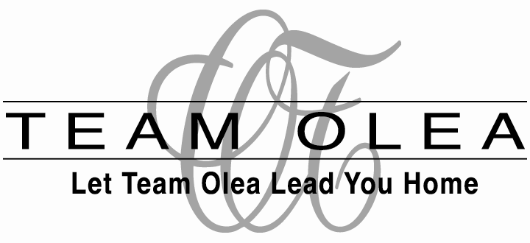

WHY TEAM OLEA?

When it comes to making a property yours the choice of who represents you can be the most important decision you make.
While choosing a realtor that is honest and knowledgeable is always a must, there are other, less obvious factors that you should consider as well.

How successful is the realtor in getting buyers into their first choice of home?
How often does their offer “win” in multiple offer situations?
What safeguards will your realtor put into the contract to protect your deposit?
What does their offer presentation look like?
What creative ideas can they recommend to make your offer better than the competition’s?
Are they usually invited to “play” in multiple counter situations?
What is their reputation among other realtors who may encourage their sellers to take or reject your offer based on your realtor’s reputation for professionalism?

From 2000-2005, of the over 70 homes we have bid on for our buyers, we have “won” the transaction for our clients over 90% of the time!
In almost every single presentation we were at the very least given the opportunity to match a higher offer, thus giving our buyer the option of negotiating. Our success rate includes dozens of multiple offer situations, even when we were not the highest bidder.

We have NEVER lost a deposit for a buyer in over 30 years of doing business.

These are quite impressive statistics, and we are proud of them.
There are a number of factors that contribute to our success.
Our focus is to do our homework up front. By being experts in our marketplace, and by taking the time to find out the seller’s needs as well as the buyer’s, we can often find a way to entice the seller to accept our buyer’s offer, while keeping the buyers’ desires in the forefront. Our long-time reputation of being honest, fair, and trustworthy ensures we are invited to negotiate, as our colleagues know that we are committed to making transactions as easy as possible for all concerned.
We are very committed to insuring a win-win situation for all parties.
Knowledge of the contracts and of the real estate industry as a whole also contributes to our success. As a buyer, it is important for you to retain control during the entire process of buying a home. The decisions will always be yours to make, and we will make sure you are in the driver’s seat throughout the entire transaction. It is our job to keep you educated, and to make sure you always have an “out” if you need it.
Our team is made up of 4 members, including an arbitration chair, ethics committee chair, CRS, Keller Williams National Rookie of the Year for 2004 and former Re/Max Broker/Owner of the Year. We employ a full time support staff to insure the highest standards of customer service are maintained.

Your success is our success.
Let Team Olea Lead You Home.

