

Your Home
Buying Packet

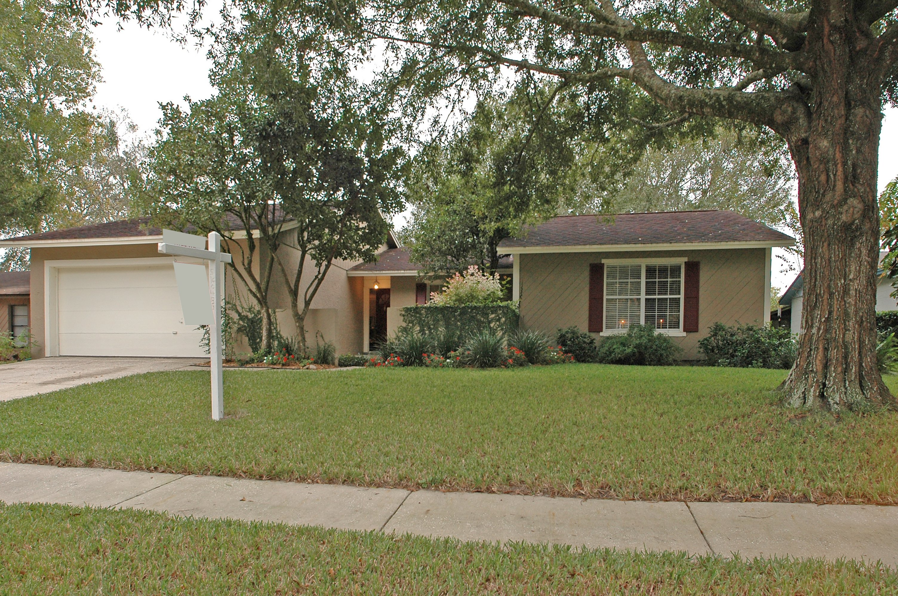
“A Straight Shot to a Successful Closing!”

with

Jeannette M. Kohlhaas
Professional Realtor
(904) 735-8666
buyandsellGOLFhomes@comcast.net

YOU ARE SMART USING A REALTOR!

As a licensed real estate professional I provide much more than the service of helping you find your ideal home. Realtors® are expert negotiators with other agents, seasoned financial advisors with clients, and superb navigators around the local neighborhood. They are members of the National Association of Realtors (NAR) and must abide by a Code of Ethics and Standards of Practice enforced by the NAR.
A professional Realtor® is your best resource when buying your home.

Let Me be Your Guide —

- As a Knowledgeable Professional Realtor® I can save you endless amounts of time, money, and frustration. There is more to buying a home, than just finding it! Buying or selling a home requires disclosure forms, inspection reports, mortgage documents, insurance policies, deeds, and multi-page government-mandated settlement statements. There are countless hours behind the scene, communication back and forth with the Sellers and your lender, title company, etc. and many deadlines to keep track of.

- As a Detailed Realtor® I know the housing market inside and out and can help you avoid the “wild goose chase.” I can give you a complete Comparative Market Analysis to show you the market value of any home and neighborhood to help you make an educated decision before you make an offer.

- As a Professional Realtor® I can help you buy any home, even if it is listed with another Real Estate Company, a builder or being sold directly by the owner. Working with your own Personal Realtor® to purchase a home can be very advantageous because someone is looking out for YOUR best interest. Buyers do not get the best representation when calling the agent on the sign, because that agent is representing their Seller, and wanting to get the highest price. For Sale By Owner’s usually have their home priced higher than market value, and are emotionally attached with their home.

- As a Skilled Realtor® I am experienced at presenting your offer to the homeowner and can help you through the process of negotiating the best price. I bring objectivity to the buying transaction, and I can point out the advantages and the disadvantages of a particular property.

- As a Full Time Realtor® I deal with Home Inspections, Termite and WDO Inspections, Surveyors, Appraisers, Title Companies, Lenders, etc. all the time. I know how to negotiate the proper terms, repair limits, etc. for your best interest. Most people buy and sell only a few homes in a lifetime, usually with quite a few years in between each purchase. And even if you’ve done it before, laws and regulations change from state to state. That’s why having an expert on your side is critical.

- As a Educated Realtor® I know the best lenders in the area and can help you understand the importance of being pre-approved for a mortgage, before we start looking for homes. I can also discuss down payments, closing costs, and monthly payment options that suit you.

- As a Well rounded Realtor®, I am an excellent source for both general and specific information about the community such as schools, churches, shopping, and transportation.

And the best thing about hiring me as your Personal Professional Realtor® is all this service and representation doesn’t cost you a cent. Typically, the Seller pays the commission to the Buyers Realtor®.

THE ADVANTAGES OF A

BUYER AGENCY & BROKERAGE AGREEMENT
Your interests are professionally represented —
Enlisting the services of a professional Buyer’s Agent is similar to using an accountant to help you with your taxes, a doctor to help you with your health care, or a mechanic to help you with your car. This is why you allow other professionals to help you in their specific areas of expertise. You know they are knowledgeable since they do their job all day long, every day, and they handle these situations all year long, not just once every 3-4 years.
I will take care of the hassles of everyday real estate transactions for you. I let you concentrate on your full-time job, while I do my job. I will guide you through the home-buying process and exclusively represent your interests as I help you find a home, present your offer, negotiate the contract, and close on your home! I will take care of the many fine details and deadlines. This is my Career!

You get your own private, personal specialist who knows your needs —
Just as your accountant, doctor, and mechanic understand your specific needs because you go to the same professional each time… as your Buyer’s Agent, I get to know your real estate needs and concerns. I listen to your feedback and concerns about each home. This type of relationship is built through open communication at all times. This is the best reason to work with ‘one’ Professional Realtor in your home search. I will save you all the guesswork by providing you with all the details about any home you are interested in. I will do in depth research so you understand the homes value and neighborhood’s Comparative Market Analysis.

You will quickly and conveniently get a great home —
The advantage to signing a Buyer’s Agency Agreement with me is that you will have a professional agent working to find and secure the ideal home for you. By law, I must represent your best interests to the best of my ability. It is nearly impossible to find a home that meets your needs, get a contract negotiated, and close the transaction without an experienced agent. You won’t need to waste gas and spend endless evenings and weekends driving around looking for homes by yourself that don’t match your ideal criteria. When you tour homes with your professional Buyer’s Agent, you will already know that the homes meet your criteria and are within your price range.

What is the Buyer’s Brokerage Agreement —
Entering into a Buyer’s Brokerage Agreement has countless advantages. When you sign the agreement, you are simply agreeing to “hire” a personal representative and be loyal to them, in helping you find a home. All of this personal service is available at absolutely NO COST TO YOU! The Seller is responsible for paying your Agent’s Commission fee. So, you get a professional agent devoted to protecting your needs, looking out for your best interests and helping you make one of the most important investment decisions of your life –- and you don’t even have to pay the fee!

THE DO’S AND DON’TS
WHILE
WE’RE LOOKING FOR YOUR HOME

While we’re looking:

DO… think out loud as we walk through the home, so I know your likes and dislikes,
wants and needs.
DO… make notes on the flier so you remember things about the home.
DO… stay together as we tour the home, so I can hear everyone’s first thoughts.
DO… ask me any questions about the home. If I don’t know the answer, I will make
notes and find out.
DO… rate each house we look at, never keeping more than the Top 3 in your mind.
DON’T… focus on the price of the home…we can Always make an offer!
DON’T… look at the Sellers furniture, pictures or belongings; focus on the size of the
rooms, upgrades, flooring, etc.
DON’T… think you’re being too picky, there IS a home out there for you!

While you’re out and about:

DO… write down the address of any home you see that you like. Call me or Email it
to me, and I will get you more detailed information about it and make an appt
for us to see it.
DO… save any ads from newspapers, magazines, etc. about a home you may be
interested in, I will call for information and an appt.
DO… drive around town to see if you like certain neighborhoods in other areas.
DO… go to open houses that look nice AND tell the Agent or Owner IMMEDIATELY
that you have a Buyer’s Agent you are working with and are loyal to.
DO… give them my card, so they can follow up with me and I can make another
appt. for us to see the home again, if you are interested. Let me know about it.
DON’T… call the other agent on the sign. He represents the seller. I will make an
appt. for us to view the home and represent You!
DON’T… disclose ANY information regarding your needs, motivation, or show any
emotions of your likes or dislikes. This could weaken our negotiating
strength.
DON’T… go to see New Model homes without me IF builders require you to be accompanied by your agent the first time, otherwise you will not be allowed to have me protect your best interests if you eventually do buy one of their homes. Ask them…GIVE them my card, and tell them you HAVE a Buyer’s Agent. DO NOT VIEW THE HOMES if they say I need to accompany you. Do NOT go into the Sales office if a sign tells you, that I need to be with you. Call me, I will show you the homes as soon as possible.

LOAN APPLICATION CHECKLIST
☑ General:
Picture ID with Social Security Number
Payment to cover application fee.
Name and complete address of all landlords (past 2 years).
☑ Income:
Employment history, including names, addresses, phone numbers, and length of time with that company (past 2 years).
Copies of your most recent pay stubs and W-2 form (past 2 years).
Verification of other income (social security, child support, retirement).
If you are self-employed: Copies of signed tax returns including all schedules (past 2 years), and a signed profit and loss statement of the current year.
If you are retired: Tax returns (past 2 years).
If you have rental property income: Copies of all lease agreements.
☑ Assets:
Copies of all bank statements from checking/savings accounts (past 3 months).
Copies of all stock/bond certificates and/or past statements/retirement accounts.
Prepare a list of household items and their values.
Copies of title documents for all automobiles, boats, or motorcycles.
Face amount, monthly premiums, and cash values of all life insurance policies (Cash value may be used for closing costs or down payments. You need documentation from the carrier indicating cash value).
☑ Creditors:
Credit cards (account numbers, current balances, and monthly payments).
Installment loans (car, student, etc.) Same details as for credit cards.
Mortgage loans (property address, lender with address, account numbers monthly payment and balance owed on all properties presently owned or sold within the last 2 years). Bring proof of sale of properties sold.
Childcare expense/support (name, address, phone number).
☑ Other:
Bankruptcy – bring discharge and schedule of creditors.
Adverse credit – bring letters of explanation.
Divorce – bring your Divorce Decrees, property settlements, quitclaim deeds, modifications, etc.
VA only – bring Form DD214 and Certificate of Eligibility.
Retirees – bring retirement and/or Social Security Award Letter.

THE TEN COMMANDMENTS
When buying a Home and
Applying for a Real Estate Loan

- Thou shalt not change jobs, become self-employed or quit your job.
- Thou shalt not buy a car, truck or van (or you may be living in it)!
- Thou shalt not use charge cards excessively or let your accounts fall behind.
- Thou shalt not spend money you have set aside for closing.
- Thou shalt not omit debts or liabilities from your loan application.
- Thou shalt not buy furniture.
- Thou shalt not originate any inquiries into your credit.
- Thou shalt not make large deposits without first checking with your loan officer.
- Thou shalt not change bank accounts.
- Thou shalt not co-sign a loan for anyone.


WORKING WITH HOME BUILDERS



Why use an Agent to purchase a new home?
The advantages of having an agent help you purchase a new home are the same as those for purchasing a resale home…
- Knowledge of the market
- Help in finding the perfect home quickly
- Expertise in contract writing/negotiation
- Closing assistance.
The builder has a professional representative watching out for his/her needs, and you need the same expert representation. You will pay the same price for the builder’s home whether you have a Realtor representing you or not. So why not have your interests protected!!!
REMEMBER – the Builder requires that your Personal Realtor accompany you on your first visit to the Builder’s sales office or Models, or they will NOT allow you to later bring in a realtor to protect your interests and they will NOT pay your agent’s fee!

Buying a new home is a little more difficult and time-consuming than buying a resale. I can professionally guide you through this process.
It is very important that your interests be professionally represented when you are entering into a contract for a semi-custom or build-to-suit home. These transactions are complex and the contract details must be exact in order to protect you and to ensure you get exactly the home you want!

MOVING CHECKLIST
☑ Two months before moving
Sort through your belongings to reduce the number of things to move.
Have a garage sale or donate items you no longer need.
Decide whether to move yourself or hire professionals. Make reservations with a moving company or truck rental company. Tip: Call three companies for estimates to compare.
Gather packing supplies: boxes, packing material, tape, felt markers, and scissors.
If you’re moving a long distance, make travel arrangements with the airline, hotel, and rental car agency. If you’re driving to your new home, get maps and plan your travel route.
Save all moving receipts. Some moving expenses are tax deductible. Check the current tax code for requirements.
Place your legal, medical, financial, and insurance records in a safe and accessible place.
Purchase insurance coverage for valuables to be moved.
☑ One month before moving
Start packing items that aren’t regularly used such as off-season clothes and decorations and items in storage areas (garage, attic, and closets).
Make travel arrangements for your pets.
If you’re driving, get your car tuned up.
Get medical records from your doctors, dentist, optometrist, and veterinarian.
Send items (rugs, drapes, clothing, quilts, bedding) to the cleaners.
Back up important computer files to floppy disk.
MOVING CHECKLIST Cont.
☑ Two weeks before moving
Contact your utility companies and notify them of your move.
Sign up for services at your new address.
Contact your long distance phone company and notify them of your move.
Call friends and family and recruit help for the moving day.
Confirm your travel reservations.
Arrange to close or transfer your bank account, if appropriate. Pick up items you’re your safety deposit box.
☑ One week before moving
Pick up items from the cleaners, repair shops, or friends.
Pack a survival kit of clothes, medicines, special foods, etc. to carry you through the day while you unpack.
Finish packing all boxes minus what you’ll need in the final week.
Inform the post office of your upcoming move.
Send change-of-address cards with your new address and phone number to:
Friends and family
Banks, insurance companies, credit card companies, and other financial institutions
Magazines and newspapers
Doctors, lawyers, accountants, realtors, and other service providers
State and federal tax authorities and any other government agencies as needed
Workplace, schools, and alma maters
☑ The day before
Set aside moving materials, such as tape measure, pocketknife, and rope.
Pad corners and stairways of house.
Lay down old sheets in the entry and hallways to protect floor coverings.
Remove hanging fixtures.
If you are moving yourself, pick up the rental truck and a dolly to move heavy boxes.
If you are driving, check oil, tire pressure, and gas in your car.
If you are flying, make sure you have tickets, charge cards and other essentials.

MOVING DAY

☑ Moving Day
Carry with you:
The keys to your new home.
A map of your new town and directions to your home.
The telephone number of the moving company.
Cash or traveler’s checks.
Documentation related to the sale of your home.
Your insurance policies and agent’s phone number.
Your current address book or personal planner.
Prescription and non-prescription medicines.
Enough clothing to get by if the movers are late.
The telephone number of the moving company.
Cash or traveler’s checks.
Any items of great personal value to you that are virtually irreplaceable.
Back-up copies of important computer files.
Sheets, towels and personal hygiene items for the first night in your new home.
☑ Arrival Day
Show movers where to place furniture and boxes.
Check inventory to ensure that everything was delivered before signing delivery papers. Note any damages on the inventory sheet.
Unpack any valuable items, such as silver, art, and jewelry, upon arrival.
Inform the post office of your upcoming move.

