Short Sale Package
Dear Homeowner:
Prior to taking your Short Sale listing, the following documents are needed for every Borrower that is on the loan(s). Please do not send over an incomplete package; please fax all documents in one fax to Keller Williams Realty- SD Metro @ 619-233-5526. The following documents are needed:

- Borrower’s Authorization
  - Complete the enclosed form with all requested information and sign & date
  - If any of your loans are with Countrywide or Bank of America, the additional Bank of America Authorization will need to be completed as well.

- Mortgage Statements
  - Provide the most recent mortgage statement for each bank (1st bank, 2nd bank, etc.)
  - Please note that these must be actual statements, which include the loan account numbers, as well as original loan balance etc.

- Hardship Letter
  - A “Hardship Letter” is a brief letter written by you, the homeowner, that briefly describes the reason for your Short Sale situation
  - Enclosed please find a sample letter - DO NOT just fill in the blanks on the form
  - Please re-write or re-type your own hardship letter - must be signed/dated

- Paycheck Stubs/Statements
  - Must have the past 3 paycheck stubs/statements; these must be the most recent.
  - If self-employed, a 6-month Profit & Loss Statement is needed

- Tax Returns
  - Copy of 2 most recent tax returns (not W-2s)
  - Only need Form 1040 (2 pages, “the summary page of your taxes”)

- Bank Statements
  - Last 3 months bank statements
  - Must include all pages of the bank statement
  - Must have your personal information printed on it (name, address, etc.)

- Financial Statement/Budget
  - Complete the enclosed form and sign & date
  - PLEASE NOTE: Most banks and bank employees will not read this document in detail, HOWEVER, in the rare occurrence that it does happen, the bank or bank employee is looking to see that your monthly obligations equal or exceed your monthly income.

- Loan Modification Waiver
  - Carefully read the enclosed form and sign & date

- Seller Expectation Document
  - Carefully read the enclosed form and sign & date

- Tenant Authorization
  - If the property is tenant occupied, both you and your tenant must complete this form.

- No Information Waiver (if necessary)
  - Please sign and date on the appropriate sections(s) of this form only if one or more of the following apply:
    - You are not employed or cannot provide Pay Stubs
    - You have not filed your taxes or cannot provide Tax Returns
    - You do not have Bank Statements or cannot provide Bank Statements

- Additional Lender Specific Forms
  - Some lenders require specific forms. If you have any of the lenders listed below, please complete the requested documents at the end of this package.
    - Bank of America/Countrywide – “Bank of America Authorization to Release Information”
    - Wells Fargo/ASC – Listing Addendum & Contract Addendum

***Again, please make sure the information requested above is provided for each borrower who qualified for the original loan.
***Please send all information in one fax – do not send in multiple faxes and do not send incomplete packages
Thank you!
Borrower’s Authorization Form

Phone: 619-248-5484 Fax: 619-233-5526

I hereby authorize Keller Williams Realty – SD Metro and its agents, specifically Lorraine Santirosa and/or its assigns, to have full access to my loan account information.

This is for the purpose of verification of account or mortgage balances, negotiation based on offers received, including but not limited to the payoff and other information pertinent to the existing financing, or the loan in any fashion. I authorize written or verbal contact with any and all lenders or note holders on my behalf, at all times, for an indefinite time period. It is also understood that a photocopy of this form will also serve as authorization.

Borrower Name Co-Borrower Name

Property Address:

Borrower’s SSN: Co-Borrower’s SSN:

First Lenders Company Name: Phone #

Loan or Account Number for 1st Lender:

Second Lenders Company Name: Phone #

Loan or Account Number for 2nd Lender:

Third Lenders Company Name: Phone # ____________ _______ __

Loan or Account Number for 3rd Lender:

As the Seller of this home, I hereby declare that this authorization form is valid and active for the entire time I have my home listed with Keller Williams Realty – SD Metro. This authorization does not expire – even if my lender(s) have some ‘guideline’ that says the authorization must be signed and dated within the last specific time period (for example the last 60 or 90 day time period) – this authorization renews automatically.

Borrower Signature Date Co-Borrower Signature Date

To Whom It May Concern,

I have been unable to make payments on my home and I am now facing a severe hardship that may result in foreclosure. My inability to keep up with my monthly payments is the result of .

I am not in a position to continue making my mortgage payments. This is not at all what I intended, but I have come to the conclusion that a short sale is my best and only option. I’m sorry this has happened. Thank you for your help and consideration in this matter.

Sincerely,

Signed and dated by ALL BORROWERS

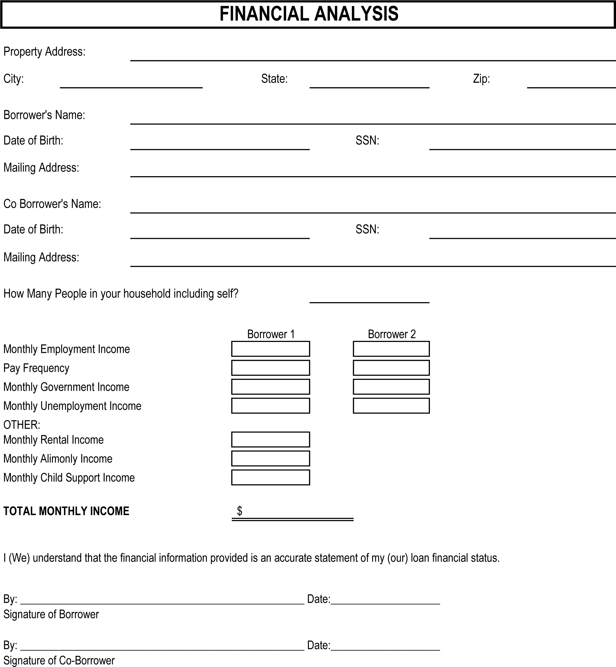
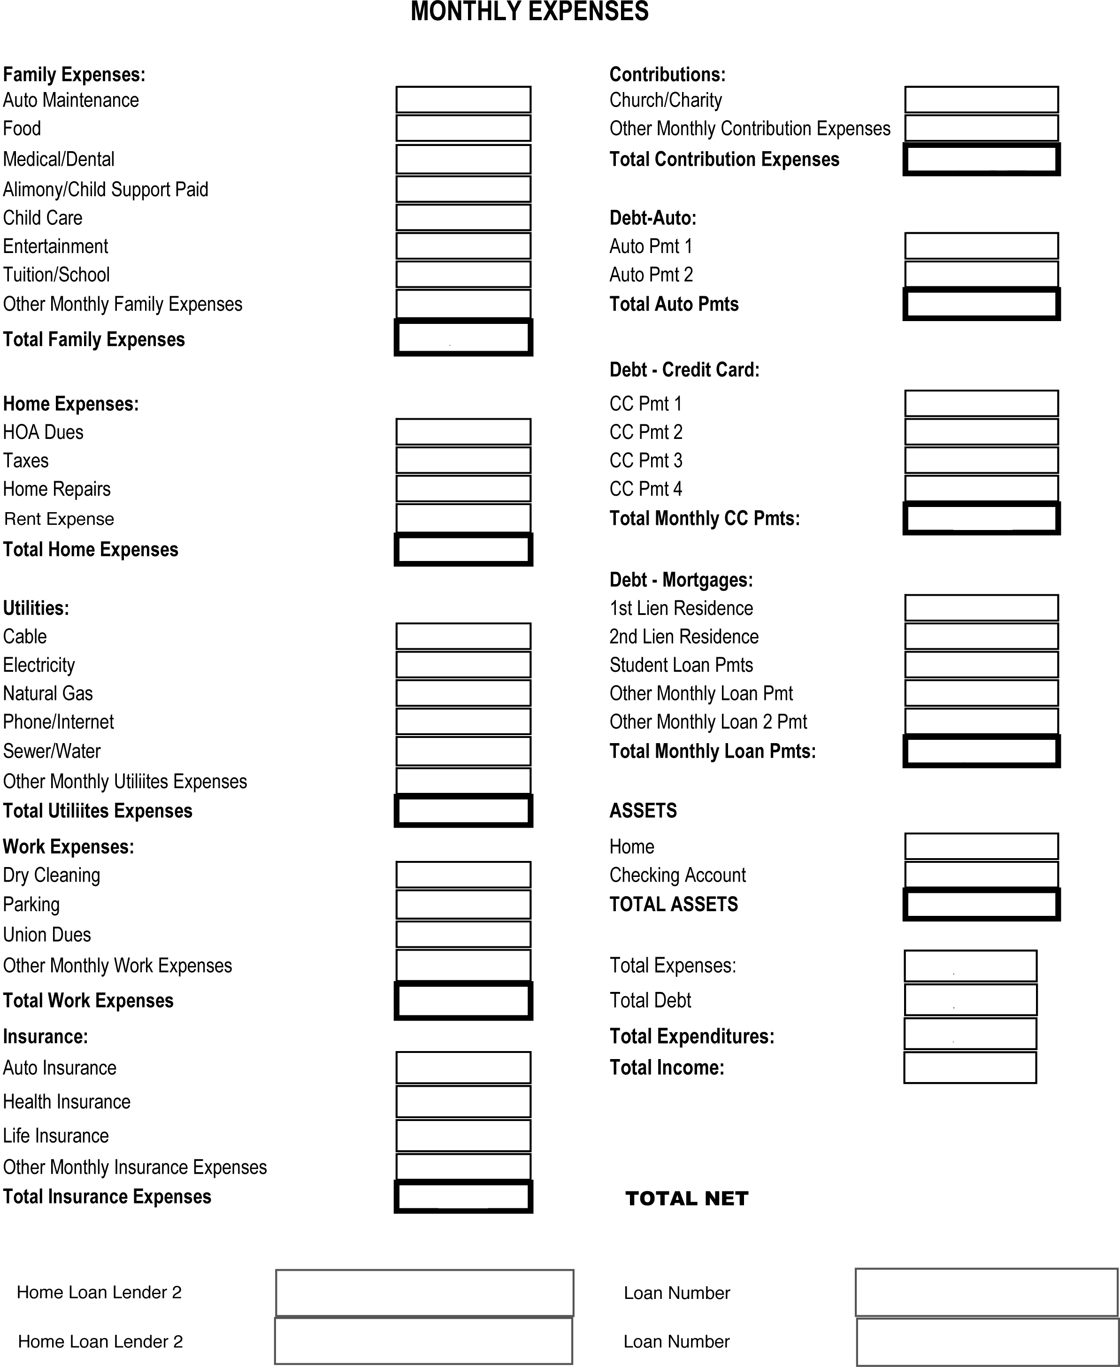

Loan Modification Waiver

I hereby acknowledge that I am not interested in any form of a loan modification on my home. By agreeing to work with Keller Williams Realty – SD Metro, I state that I am 100% committed to selling my home through a Short Sale. I understand that once I have hired Keller Williams Realty to complete my Short Sale, that it is not uncommon for my bank(s) to begin offering various loan modification plans as a strategy for my bank(s) to collect more money from me.

This form is an acknowledgement to Keller Williams Realty – SD Metro and my bank(s) that I have no interest in a loan modification. I am only interested in selling my home via a Short Sale.

Borrower & Co Borrower Names:

Property Address:

Signature Date

Signature Date

Keller Williams Realty–SD Metro Short Sale Process and Seller Expectations

Thank you once again for choosing to work with Keller Williams Realty- SD Metro. We know that this time can be very difficult on you. It is our objective to help you Short Sale your home and move forward from this period in your life as quickly as possible. This document was created to inform you of how we process all of our Short Sale listings and the expectations that we place on you, as the Seller of the home.
Please read through this entire document and sign/date the last page, to acknowledge your acceptance of our Short Sale process and the expectations you will be held to.

Who We Are
We are the premier short sale team in the San Diego area, specializing in helping homeowners that owe more against their home than it is currently worth- selling their home without bringing any money to closing. We specialize in the negotiation process with banks. Homeowners hire us because they understand the value that we offer. This value comes from our experience, results, and process.

Experience
As an office we have more than five years in negotiating and successfully closing short sales. All of our short sale negotiation is done “in-house.”

Results
While we will never guarantee that we can close every short sale (and we think you should be really leery of anyone that tells you they can), we strongly believe that if it is a deal that can be done, we will get it done!

Process
We believe that we have a Short Sale process that is unmatched in the industry. From our initial consultation with you all the way through and after the closing, we have a process in place that delivers results and aims to eliminate potential problems. Our process is actually pretty simple – it’s all the other Realtor’s Short Sale processes that are confusing and make no sense (we’re somewhat kidding). Here’s our process…

- Prior to taking your Short Sale Listing, we collect the “Financial Package” from you, which includes all of the information your bank will request from us.

- You list your home with your preferred Listing Agent and the day the home goes in MLS, we send the Borrower’s Authorization Form to the bank. This document allows us to communicate with your bank directly.

- Your Listing Agent markets your property and prices the home at, or slightly below, market value until we get an offer

- We are only looking for ONE contract to send to the bank. We are looking for ONE qualified Buyer with an appropriate offer price that has serious intentions on closing the transaction. If we have this, we will fully execute ONE contract to send to the bank.

- Once an offer is received on your property, your Listing Agent will quickly review that offer with our team and then will contact you and send you the offer that was received for your signature and initials. This offer will have been reviewed to ensure all terms will meet the lenders’ requirements. In some cases, a counter offer will be generated to ensure the offer meets all necessary terms. It is imperative that you send that contract back to your Listing Agent immediately, as the contract is time sensitive. If you have any questions regarding that contract, please address those with your Listing Agent before signing anything. Upon acceptance, we will also request that you send updated Bank Statements and Pay Stubs along with the signed contract.

- Once the contract is fully executed, we submit the fully executed contract, a HUD-1, and all of your financial documents to the bank to begin the 60-90 day Short Sale process (this is the average length of processing time – some are much quicker, some take up to 90 days). Please be patient throughout this process. At times you may feel things are moving slowly, but remember: this is not a regular transaction and we are doing all we can on our end to make things go as quickly as possible.

- Your bank(s) will then do one or more valuations on the home to identify what they think the home is worth. Once their valuations are back, they’ll review the offer and all corresponding documentation and finally issue their decision.

- Once the bank accepts the terms of the offer, we’ll issue a document called the Agreement Notice – the notice to all parties that the Short Sale has been approved. In rare circumstances, we will need to go back to the Buyer and tell them why the bank will not accept their offer and give them an opportunity to raise their offer.

Marketing Your Home
Your home will be shown to both investors and traditional buyers through the MLS and many other websites. It is a requirement of ours that your home has a lockbox on it for easy showing access. Statistics have shown over and over again that homes with lockboxes on them sell much faster than those that are by appointment only.

During this process, your home may be shown several times a day. It is your responsibility to make sure the home is in good showing condition and is available to be shown in an appropriate and timely manner. Our mutual goal is to get the highest and best offer in the shortest amount of time. While your home is being shown by other Realtors, please be sure to direct any non-property related questions to your Listing Agent.

Part of having your home in good showing condition includes keeping all utilities (electricity, water, gas, sewer, etc.) on at the home for the duration of the sales process. Per the Exclusive Right To Sell/Listing Agreement, it is the Seller’s responsibility to keep all utilities on while marketing the home as well as while we are in the negotiation and closing process. It is imperative utilities are on at the time of the Buyer’s home inspection.

Marketing a Home with Tenants
On some occasions, the homes that we list are tenant-occupied rather than owner-occupied. In this situation, it is imperative that you are in full communication with your tenant. Your tenant must agree to sign an agreement with you to vacate the property within 2 weeks of the bank agreeing to the short sale.

Additionally, we will not list any homes that are tenant-occupied without the written consent of you and the tenant to allow a lockbox on the property and any and all showings of the property with 1 hour advanced notice. We will not list a home if the tenant is not cooperative with any of the above points.

We have created a Tenant Acknowledgement form for you to use with your tenants. This form entails all of the points covered above and must be signed by you and your tenants prior to the listing of your home.

Items in Home:
We understand that there are items in your home you may not want to part with; however, there are several items in every home that are considered “fixtures” according to the sales contract. The following items are considered a fixture and are expected to convey with the home:
- Range/Oven | - Built In Appliances | - Light Fixtures
- Towel, Curtain & Drapery Rods | - Ceiling Fans | - Draperies/Blinds
- Attached Floor Coverings | - Flush Mounted Speakers | - Attached Fireplace Equipment
- Window & Door Screens/Sun Screens | - Shutters & Awnings | - Solar Systems
- Attached TVs & Satellite Dishes | - Storage Sheds | - Water Misting Systems
- Garage Door Openers & Controls | - Timers | - Mailboxes
- Outdoor Fountains and Lights | - Built In Barbeques | - Outdoor Fireplaces

If you wish to remove any of the above items, they must be removed prior to the listing appointment and/or any property showings.
Although the property will be offered “AS-IS”, the Buyer is entitled to perform inspections to determine their satisfaction with the conditions of the property. In compliance with the AAR As-Is Addendum, the property must be in the SAME condition on the date of close of escrow as it is on the date the offer is produced. Any changes to the condition of the property can seriously jeopardize the pending close of escrow.

HOA
Your Homeowner’s Association has the ability to file legal action against you for delinquent HOA Dues and/or Fines. Several lenders will not authorize the payment of past HOA dues, penalties or fines. We strongly recommend that you keep your HOA dues current and abide by all rules and regulations of the HOA in order to avoid any penalties.

Communication from Us
To keep you informed throughout the transaction, we have developed a system which will enable you to get updates on your transaction on a regular basis. We use an online transaction management system. As a courtesy, we will send biweekly email updates to you. We ask that you read your email.

Communication from You
If you receive any documentation in the mail from your bank(s) outside of a standard collection letter, please email or fax us this documentation as soon possible. Of specific interest to us is anything with a foreclosure sale date on it – especially if your home is in San Diego County (It is very difficult for us to research foreclosure sale dates in San Diego County).

Unless we instruct you to do so, we ask that you have no contact with your lender(s) throughout the Short Sale process – any contact from you to your lender(s) only complicates the process. If we do need you to contact someone at the bank, we will instruct you to do so and ask that you make this contact within 24 hours from the time we make the request.

Short Sale Approval
Once the offer has been approved by the lender(s), you will be notified through a document called the Agreement Notice that we can now proceed with closing on the transaction. Our standard Short Sale Addendum, included with every fully executed contract, states the close of escrow will take place 21 days from the date of lender(s) approval. If you are still living in the home at this time, you must be prepared to move out before the closing.

Closing Process
After the issuance of the Agreement Notice, the escrow/title company will contact you to schedule a time to sign the official seller closing documents. Our escrow/title officer is able to sign you at the main office in Hillcrest. If you desire to be signed at a different location, there will be a $250 fee for a mobile signer to meet you at the location of your choice. Please note that there are no alternative closing arrangements that can be made. Please bring your I.D. and a good attitude with you to sign closing docs. ☺ Please arrange with us to turn over all keys, and garage door openers on the day of closing.

Your Future Financial Freedom
Keep all documents pertaining to this sale in a safe place. Please call us with your new forwarding address so we can keep in touch with you. Try not to incur any new debt and try to keep low balances on any credit cards you may have. Maintain good consumer credit by not paying late on your currently active accounts. Pay your rent by check or some other way that can be tracked to show evidence that you are paying on time. These things will assist you should you choose to purchase a new property in the near future.

We understand this decision may have been very difficult to come to. With that said, we would like to remind you that the whole purpose of this transaction is to position yourself and your family in a better place; a place with a healthier financial future and one which allows security and freedom.

We look forward to working with you toward a successful transaction!

Best Regards,

Lorraine Santirosa
Keller Williams Realty – SD Metro

Seller Expectations Acknowledgement Form
I , as seller of the property located at agree to the following:

/ To keep the subject property in good showing condition, including, but not limited to, keeping all utilities on through close of escrow.

/ To submit written authorization signed by tenant (if applicable) allowing a lockbox on the property, showings with 1 hour notice and agreement to vacate the property within 2 weeks from delivery of Agreement Notice.

/ To respond to all Realtor requests for showings within 24 hours.

/ To direct any non-property specific questions from Realtors to my Listing Agent.

/ To deliver any requested items, including contract and updated financials within 36 hours of request to my Listing Agent.

/ That no items considered a fixture (as defined on page 2 of this document) will be removed from home after home is listed.

/ That home will be left in the same condition at close of escrow as it was at time offer was made.

/ That I/we will contact Keller Williams Realty – SD Metro upon receipt of any communication from my lender(s) with regards to anything other than standard collections.

/ That I/we will notify Keller Williams Realty – SD Metro immediately if I receive anything with regards to a foreclosure sale date on my property.

/ In the event that I am asked by Keller Williams Realty – SD Metro to contact my lender, I will do so within 24 hours of that request.

/ To respond to any phone calls or emails from the Title Co. within 24 hours.

/ To notify Keller Williams Realty – SD Metro of any changes in property status, including, but not limited to, vacating the home, going out of town while home is occupied, and/or any changes in tenant status.

/ To allow BPO Agent, Appraiser, and Inspector access within 24 hours of request.

/ I certify that I have read and fully understand the entire Seller Expectation document.

Seller’s Signature Date

Seller’s Signature Date

Tenant Authorization

I/we, as tenant(s) of property located at

, have been made aware that the above mentioned property is being listed for sale.

I understand that a sign will be posted in the front yard, and that Realtors will be showing the home.
Showing Instructions:

Realtors may call me to show the home; if I do not answer the phone, they may leave a message and show the property using a lockbox put on the home.

Realtors may show between the hours of ______ and ______ without calling (using lockbox). Other than these hours, they must call to arrange a time to show.

Tenant Phone Number:

Furthermore, I agree that upon notification the home will be closing or that contract has been fully accepted, I will have two (2) weeks to vacate the property in good condition.

Tenant Date

Tenant Date

Owner Date

Copies of last 3 Pay Stubs

I/We are unemployed or do not have Pay Stubs to provide.

Borrower Signature Date

Co-Borrower Signature Date

Copies of last 3 months Bank Statements
I/We no longer have a bank account or are unable to provide Bank Statements.

Borrower Signature Date

Co-Borrower Signature Date

Copies of last 2 Years Tax Returns
I/We have not done my/our taxes for the past 2 years or we are unable to provide tax returns.

Borrower Signature Date

Co-Borrower Signature Date

If any of your lenders are:

Bank Of America
Countrywide
Wells Fargo
America’s Servicing Company (ASC)

There are additional forms after this page for you to complete.
